# Radioactivity

## Stable and unstable nuclei

Stable nuclei of low mass have approximately equal numbers of neutrons and protons. The trend we can see in the diagram is that the ratio of neutrons to protons increases for the larger stable nuclei.

We can explain this by considering the repulsive electrostatic force between protons and the attractive nuclear force between the nucleons. As the number of protons increases, more neutrons are needed to overcome the coulomb repulsion. Eventually, as more protons are added, the repulsion becomes too great and the addition of more neutrons cannot make the nuclei stable. The key to explaining this is that the electrostatic force is long-range, while the nuclear force is short-range, effectively acting on adjacent nucleons.

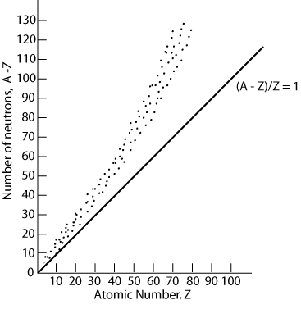

### Features of stable nuclei

* No stable nuclei exist past Z=83.
* Stable lower mass nuclei have approximately equal numbers of protons and neutrons
* Stable larger mass nuclei have more neutrons than protons
* No stable nuclei with more protons than neutrons

### Types of decay of unstable nuclei

We will be looking at four types of decay:

* Alpha $(α)$ decay
* Beta minus ( $β^{-})$ decay
* Beta plus ( $β^{+})$ decay
* Spontaneous fission

### Alpha decay

Alpha decay occurs for heavy unstable nuclei with Z > 83. Due to the high binding energy of the alpha particle, the emission of the helium nuclei is often energetically favoured. The daughter nucleus will be more stable than the parent nucleus, but it may still be unstable and decay further. The general equation of an alpha decay is:

$${}_{Z}^{A}X→{}_{Z-2}^{A-4}{Y+}α$$

For example consider the decay of polonium-214:

$${}_{85}^{214}{Po}→{}_{82}^{210}{Pb+}{}_{2}^{4}{He}.$$

This reaction is exothermic (${}_{85}^{214}{Po}, 213.995 \text{amu}; {}_{82}^{210}{Pb}, 209.984\text{ amu}; {}_{2}^{4}{He},$ 4.003 amu). However, the emission of only one nucleon is not exothermic:

$${}_{85}^{214}{Po}→{}_{84}^{213}{Bi+}{}_{1}^{1}p,$$

(${}_{84}^{213}{Bi}$, 212.994 amu; ${}_{1}^{1}p$, 1.008 amu).

­

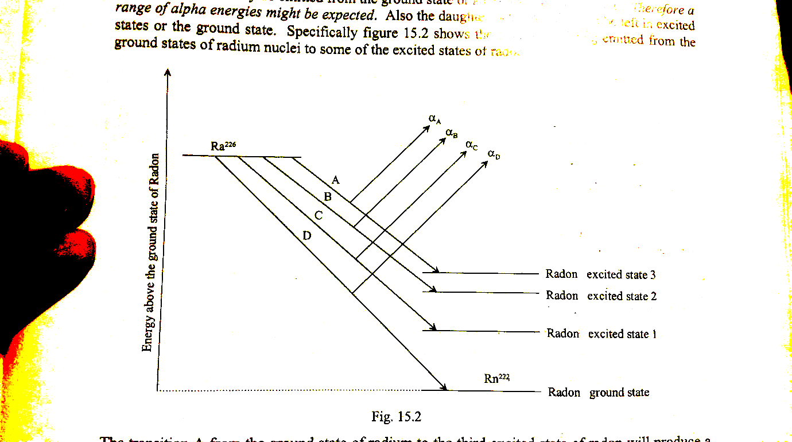The excess energy of the reaction is released in the form of kinetic energy (mainly with the alpha particle) and as gamma radiation, which we discuss later. An interesting property of alpha decay is that the alpha particles are emitted with different discrete energies, depending on the nucleus. In fact, this is evidence that the nuclei have discrete energy levels, analogous to electron shells.

For example, consider the alpha decay of radium to radon on the energy level diagram above. The alpha particle may be emitted from the ground state or an excited state of radium. As well, the daughter nuclei could be left in a number of states. Hence there are a range of alpha particles that can be emitted, with discrete energy levels.

If the daughter nuclei is left in an excited state, a photon will be emitted when the nucleus returns to the ground state, in a process similar to fluorescence. However the energies are in the MeV range and so the photons will be high energy, high frequency gamma radiation. Similarly, the gamma photons emitted will have discrete energies corresponding to the transitions taken to get to the ground state.

1. State the charge, mass and nature of alpha emissions.
2. Explain why the emitted alpha particles have discrete energies.

### Beta decay

There are two types of beta decay involving the conversion of neutrons to protons and vice versa.

Beta minus decay occurs when a nucleus has an excess of neutrons, and a neutron is converted into a proton. When a neutron decays it produces a proton and an electron and an antineutrino, $\overline{{}_{0}^{0}ν}$ (or $\overline{ν}$):

$${}_{0}^{1}n→{}_{1}^{1}p+{}_{-1}^{0}e+\overline{{}_{0}^{0}ν}.$$

The general equation is given by:

$${}_{Z}^{A}X→{}_{z+1}^{A}Y+{}_{-1}^{0}e+\overline{{}_{0}^{0}ν}.$$

Beta plus decay occurs when a nucleus has an excess of protons, and a proton is converted into a neutron. When a proton decays it produces a neutron and a positron, ${}_{+1}^{0}e$ (or $e^{+}$), and a neutrino, ${}_{0}^{0}ν$ (or $ν$):

$${}_{1}^{1}p→{}_{0}^{1}n+{}_{+1}^{0}e+{}_{0}^{0}ν.$$

The general equation is given by:

$${}_{Z}^{A}X→{}_{z-1}^{A}Y+{}_{+1}^{0}e+{}_{0}^{0}ν.$$

#### Neutrino and antineutrino

Early studies of beta decay did not detect the neutrino or antineutrino. Experimental data showed that the electron in beta minus decay is ejected with a range of kinetic energy values up to the predicted maximum and also at different angles to the daughter nucleus. This would violate both conservation of momentum and energy, unless a third particle was also ejected. Wolfgang Pauli in 1930 postulated the existence of such a particle and it was discovered experimentally in 1956.

The neutrino and antineutrino:

* Have no charge
* Have a very small rest mass
* Travel at the speed of light
* Can be assigned an energy and a momentum

#### Antimatter

The antineutrino and positron are examples of antimatter: particles that share the same mass as their matter counterparts, but qualities such as electric charge are opposite. When a particle and its antiparticle counterpart come together, they annihilate and leave behind energy in the form of gamma photons. Momentum and energy is conserved in the annihilation process. Later we will see that positron-electron annihilation is the key principle behind PET (positron emission tomography) scans.

1. The isotope 235U decays into another element, emitting an alpha particle.
   1. What is the element?
   2. This element decays, and the next, and so on until a stable element is reached. The complete list of particles emitted in this chain is:   
        
      What is the stable element X? (You could write down each element in the series, but there is a quicker way.)

The complete decay chain involves the loss of seven alpha particles () and four beta particles (). This represents a loss of 7  4, i.e. 28, in mass number and (7  2 – 4), i.e. 10, in atomic number. X is therefore an isotope with mass number (235 – 28), i.e. 207, and atomic number (92 – 10), i.e. 82. This is lead,.

1. Justify the emission of a neutrino in beta plus decay using conservation laws.

### Gamma decay

After alpha or beta decay, a nucleus is sometimes left in an excited state, denoted ${ X}^{*}$. Like an atom in an excited state, the excited nucleus decays by emitting one or more photons, in this case a high energy gamma photon. The gamma ray has no charge and no rest mass.

The general equation for a gamma decay is given by:

$${}_{Z}^{A}{X^{*}}→{}_{Z}^{A}X+nγ$$

As mentioned previously, the number of gamma photons emitted depends on the transitions of the nucleus down to the ground state, as shown in the example below. The energy of the gamma rays correspond to the discrete energy levels of the excited states.

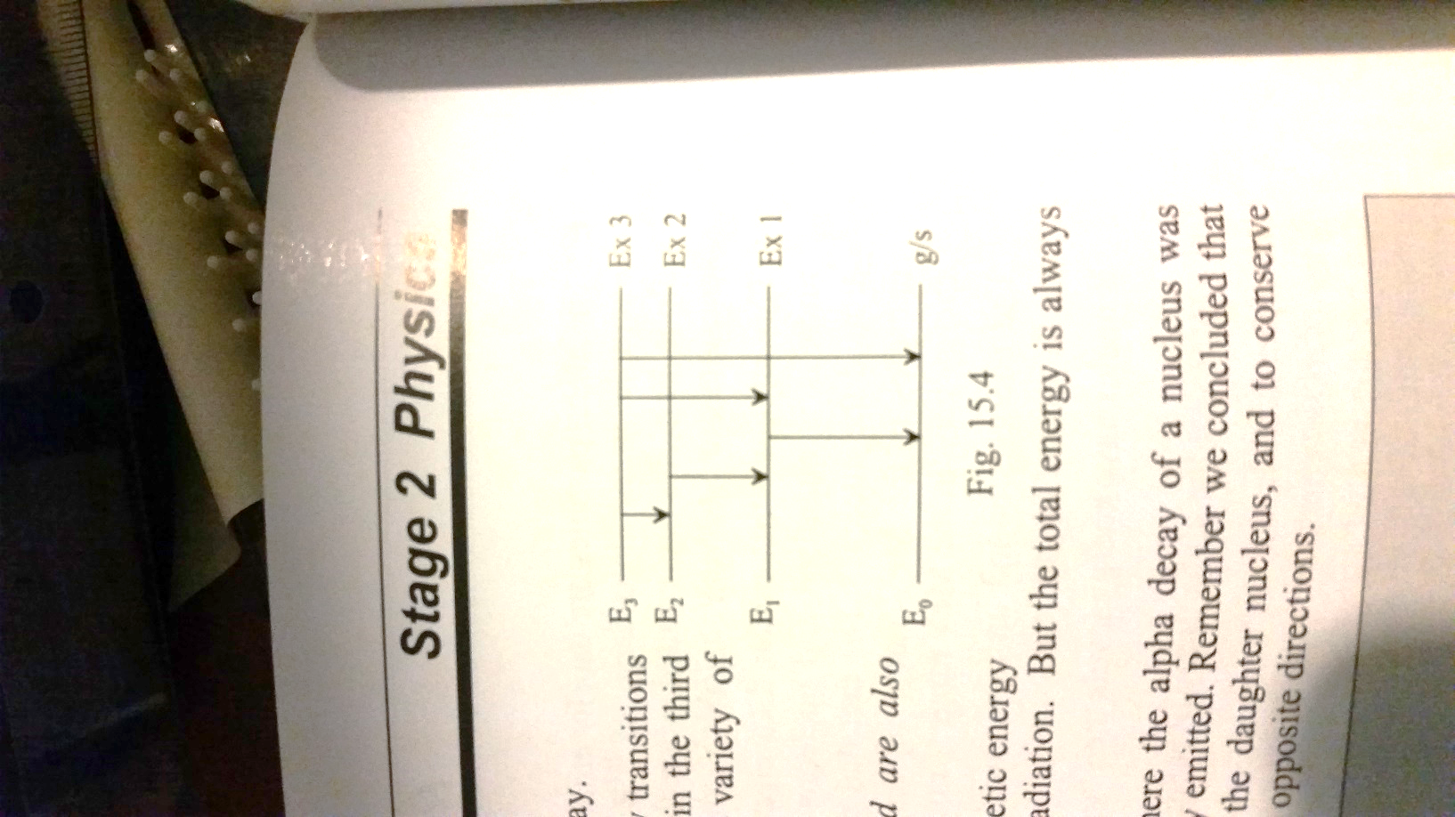

1. Explain why alpha or beta decay is often accompanied by the emission of gamma rays with discrete energies.

### Spontaneous fission

Spontaneous fission is a form of radioactive decay that only occurs for very heavy nuclei. In this decay process, the nucleus will split into two nearly equal fragments and several free neutrons. A large amount of energy is also released. Most elements do not decay in this manner unless their mass number is greater than 230.

For example, uranium-238 is a naturally occurring atom know to spontaneously decay by fission. However, in the case of uranium-238, alpha decay occurs much more frequently.

### Decay trends in the N versus Z graph

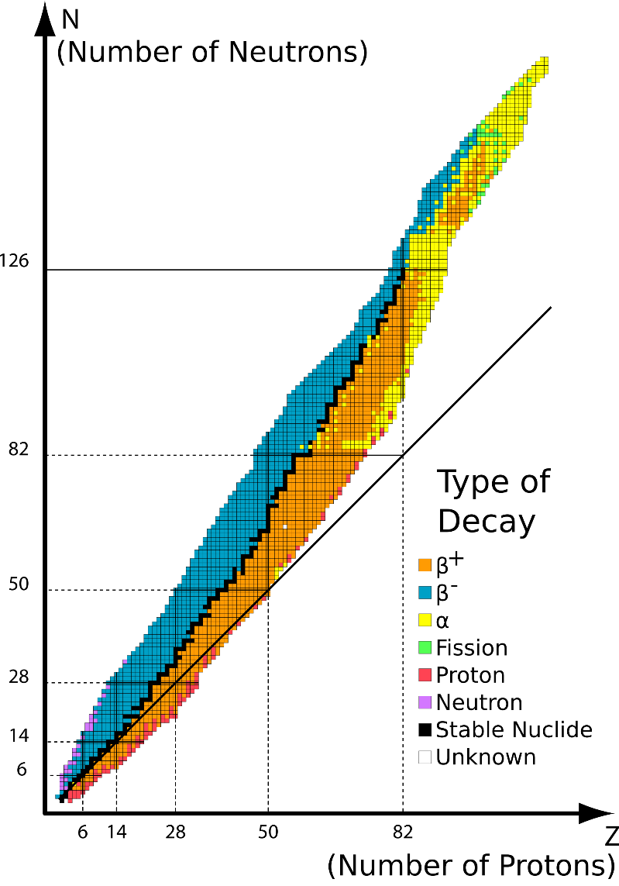In the N versus Z graph, we can see a general pattern in the types of decay a nucleus undergoes:

* Alpha decay occurs for nuclei with Z > 83
* Beta minus decay occurs for nuclei above the graph of stable nuclei.
* Beta plus decay occurs for nuclei below the graph of stable nuclei.
* Spontaneous fission occurs for some nuclei with Z > 83

1. Can you explain why the types of decay correspond to the different regions?
2. Using the graph, predict and explain the type of decay that nitrogen-13 undergoes:

## Some properties of radioactive emissions

Alpha, beta and gamma radiation ionise the material through which they pass. Ionising radiation can be subatomic particles moving at very high speeds (alpha and beta particles) or electromagnetic waves with high frequency (for gamma rays). Ionising radiation has enough energy to free electrons from atoms or molecules, thus ionising them. Charged particles can ionise atoms directly through the Coulomb force, while photons can ionise atoms through the photoelectric effect and Compton scattering. The charged particles can go on to produce further ionisation.

### Alpha radiation

Alpha particles have a large mass and +2 charge. They are also ejected with high kinetic energies. Alpha particles are able to collide with atoms and knock out electrons by mechanical collision as well as the Coulomb force. Due to the collisions, alpha particles lose kinetic energy quickly and do not penetrate far.

### Beta radiation

Beta particles are much smaller than alpha radiation and have half the charge. As a result they are less likely to ionise atoms by collision or by the Coulomb interaction. Beta particles can penetrate much further into matter than alpha particles.

### Gamma radiation

Gamma rays have no mass or charge and hence their interaction with matter is less than alpha and beta radiation. The ionising power is very low and gamma photons can penetrate very deeply into matter before their energy is absorbed.

### Penetration power

In general, the more ionising the radiation, the lesser the penetration power because kinetic energy is lost in the interaction with matter. Gamma radiation is more penetrating than beta radiation and beta radiation is more penetrating than alpha radiation. Alpha particles are stopped by a sheet of paper, or a layer of dead skin cells. Beta particles will penetrate paper but be stopped by a denser material such as aluminium. Gamma radiation will pass through all but thick slabs of lead and concrete. 1 cm of lead or 6 cm of concrete will reduce the intensity of the gamma radiation by half.

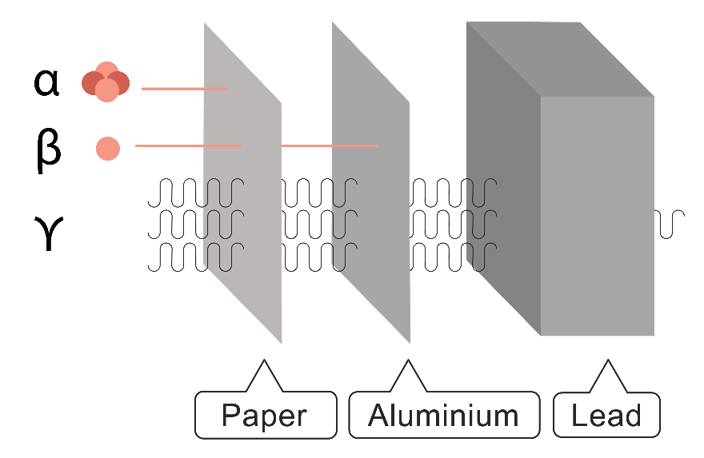

### Effects of electric and magnetic fields

Alpha particles and beta particles, as moving charges, will experience a force in both an electric and magnetic field. Gamma radiation will pass through an electric field and a magnetic field undeflected because it has no charge.

In an electric field:

* The force is determined from F=Eq.
* Positive charges move in the direction of the electric field, negative charges move opposite to the electric field.
* If the initial velocity of the radiation is parallel to the electric field, then the motion is analogous to freefall.
* If the initial velocity is perpendicular to the electric field, then the motion is analogous to projectile motion, with the alpha or beta particle tracing out a parabolic path.
* An alpha particle will experience a smaller acceleration than a beta particle, due to its larger mass. Hence the deflection in the electric field will also be less.

In a magnetic field:

* The force is determined by F=qvB.
* The direction of the force is determined using the right hand rule.
* The force is always perpendicular to the motion of the charged particle, resulting in centripetal acceleration.
* Given the same initial speed, since the radius of the circular path is $r=\frac{mv}{Bq},$ the alpha particle move in a circular path with a much greater radius.

1. Determine the radiation from the deflection in the electric field:

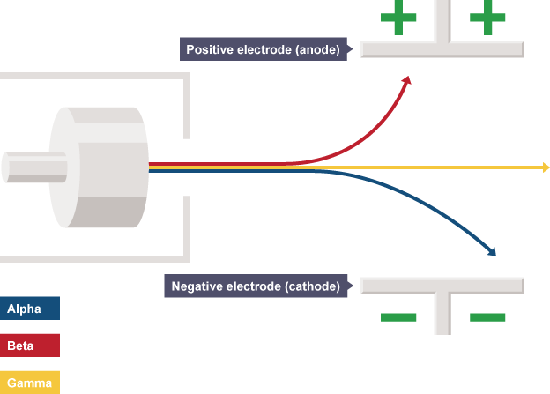

1. Sketch the deflection of alpha, beta plus, beta minus and gamma radiation in the given magnetic field:



Radioactive source

$$\vec{B}$$

1. Complete the following table comparing the properties of the types of radiation.

|  |  |  |  |
| --- | --- | --- | --- |
| Decay | Alpha, $α$ | Beta particles, ${β,}^{-}$ $β^{+}$ | Gamma, $γ$ |
| General Equation |  |  |  |
| Charge |  |  |  |
| Mass |  |  |  |
| Speed | $${10}^{7}ms^{-1}$$ | $${2×10}^{8}ms^{-1}$$ | $${3×10}^{8}ms^{-1}$$ |
| Ionising ability |  |  |  |
| Penetrating power |  |  |  |
| Discrete energies? |  |  |  |
| Deflection by electric/magnetic fields |  |  |  |

## The effect of ionising radiation on living matter

Other examples of ionising radiation besides from alpha, beta and gamma radiation are: UV radiation, x-rays and protons and neutrons.

Ionising radiation can break chemical bonds in living matter. Possible effects are:

* Breaking down molecules vital to cell function
* Forming acidic substances which chemically attack cells
* Altering genetic material in such a way that cells die
* Mutations in DNA which can cause cancer or genetic defects to be passed on to offspring

Sources of ionising radiation are:

* Cosmic radiation, either from the sun or outside the solar system. The radiation can be in the form of UV, high energy protons and other high energy particles.
* Background radiation due to the natural decay of radioactive isotopes in rocks and structures of earth.
* Common examples are bananas containing potassium-40 and radon gas radioisotopes found in cellars and the foundations of a house.
* Medical radiation, for example from x-rays or injection of medical radio isotopes.

Radiation dosages can be minimised by:

* Increasing distance from the source
  + Using tongs to handle radioisotopes
  + Chernobyl exclusion zones
* Limiting time of exposure
  + Electronic Personal Dosimeter to monitor radiation for people working near sources of ionising radiation
  + Short bursts of high radiation are especially damaging
* Using adequate shielding
  + Gloves stop alpha and beta radiation
  + Concrete around nuclear power stations
  + Lead aprons when taking x-rays

1. In some cases alpha radiation is the most dangerous radiation to us and in some cases it is not. Explain why.
2. What simple test could you use to decide the type of radiation being emitted from an unlabelled source in a lab?
3. Explain how ionising radiation can damage living matter.

## Half-life and activity

Radioactivity is a random process, which we can model mathematically. The number of radioactive nuclei, N, at time t, in a sample decays exponentially with time:

$$N(t)=N_{0}e^{-kt},$$

Where $N_{0}$ is the initial number of nuclei present at t=0 and k is the decay constant.

The half-life, denoted ${ t}_{1/2}$, is defined as the time it takes for half the remaining atoms in a sample to decay.

Radioactivity is a random process with a constant probability of decay, hence the half-life of an element will be constant. In the same way that isotopes are indistinguishable in nature, the rate of radioactive decay is not affected by the physical or chemical state of the material because the decay is a nuclear process.

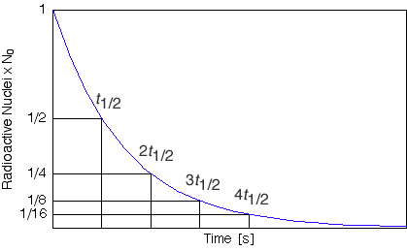

It is often more convenient to consider the activity of a radioactive substance instead of the number or radioactive nuclei. The activity of the decay is defined as the number of nuclear decays per second, which is the rate of decay. The activity can be measured using a Geiger counter that detects the number of nuclei that decay in a given time. The unit of activity is the becquerel (Bq). One Becquerel is equal to one decay per second. Since the number of decays is proportional to the number og atoms remaining in a sample, the activity also decreases exponentially with time and has the same decay constant and hence, half-life:

$$A(t)=A_{0}e^{-kt},$$

where A is the activity at time t, $A_{0}$ is the initial activity at t=0 and k is the decay constant.

1. Estimate the half life of carbon-14:

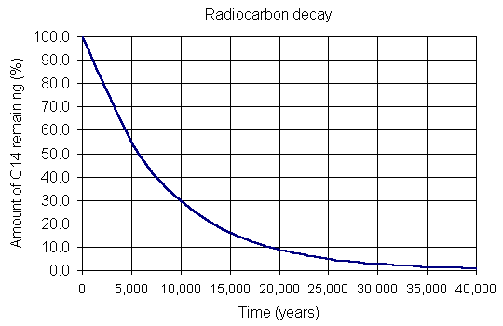

1. Beryllium-11 has a half life of 13.81 seconds. If an initial sample has 10 000 radioactive nuclei, how many remain after 41.43 seconds?
2. Nobelium-253 has a half-life of 97 seconds. If a sample initially has an activity of 60 Bq, what is the activity after 4 half-lives?
3. Carbon-15 has a half-life of 2.5 seconds. Sketch a graph of activity versus time for a sample with an initial activity of 50 Bq.

## Positron Emission Tomography (PET)

PET uses radioisotope tracers to detect abnormal functions in bodily organs. Radioisotopes are incorporated into biological molecules (glucose, water, ammonia etc.). As chemical reactions do not distinguish between isotopes of the same atom, the radioactive isotopes can be concentrated in body tissues in the same way that stable atoms are.

Where the molecule ends up in the body can be very informative. For example, labelling glucose with fluorine-18 to make FDG (fluorodeoxyglucose) will indicate areas of high metabolic activity, for example in cancerous cells. Oxygen-15 is another radioactive isotope which can be incorporated into water and used to monitor blood flow through a tissue.

Both fluorine-18 and oxygen-15 decay by beta plus decay, which is the basis of PET analysis:

$${}_{9}^{18}F→{}_{8}^{18}O+e^{+}+\overline{ν}$$

$${}_{8}^{15}O→{}_{7}^{15}N+e^{+}+\overline{ν}$$

The emitted positron travels about 0.5 mm before losing its energy and slowing down. Then it collides with an electron in the tissue in a process called positron-electron annihilation, producing two gamma rays. As a result of the law of conservation of momentum, the total momentum of the gamma photons must be zero, assuming an initial momentum of zero. Therefore, photons of equal energy will move in random directions, opposite to each other.



The PET analysis uses a scanner to detect the emitted gamma rays. A computer analyses the results to match photons emitted at roughly the same time but opposite directions. The annihilation event will be located somewhere on the line connecting the two photon detection points. Newer systems use the slight difference in the time of flight of the photons to identify the most likely location of the annihilation event.



Positron emitting isotopes used in medical imaging tend to be short-lived, in order keep patient radiation dose low and have more photons to image. For example, fluorine-18 has a half-life of 110 minutes, while oxygen-15 has a half-life of 2 minutes. This means the PET facility needs to close to a particle accelerator so that the radioisotope can be inserted rapidly.

1. Assuming negligible kinetic energies of the positron and electron, calculate the energy of the emitted photons produced in positron-electron annihilation.
2. Research the uses of oxygen-15 and fluorine-18.
3. Describe how a ring of photon detectors allows the location of a tracer radioisotope in a human body to be determined.
4. Describe how the beta plus decay of a radioisotope can result in the production of photons through positron–electron annihilation