STAGE 2 PHYSICS

READING

Key Ideas pg
Motion in 2 Dimensions
Projectile Motion

In the absence of air resistance, and moving under the action of a constant gravitational force, a projectile has a constant acceleration in the direction of the force. The horizontal component of velocity of such a projectile is constant, and the vertical component changes at a constant rate. The time of flight and the range of the projectile are calculated, and the effect of air resistance on the motion is treated qualitatively. These key ideas are applied to projectiles in sport (e.g. a shot put).

Key Ideas | Intended Student Learning
Vertical and Horizontal Components of Velocity

For a projectile, in the absence of air resistance, the:  horizontal component of velocity is constant  acceleration is in the vertical direction and is the same as that of a vertically free-falling object. | Given a multi-image photograph of a projectile, demonstrate that the:  horizontal component of velocity is constant  acceleration is in the vertical direction and is the same as that of a vertically free-falling object.
The horizontal motion and the vertical motion are independent of each other: the constant vertical acceleration is independent of the horizontal speed. | Draw a vector diagram in which the horizontal and vertical components of velocity are added, giving the resultant velocity vector at any instant.
The acceleration of a projectile, in the absence of air resistance, is in the direction of the gravitational force. | Using trigonometric calculations or a scale diagram, calculate, from its horizontal and vertical components, the magnitude and direction of a velocity vector at any instant.
 | On a diagram showing the path of a projectile, draw vectors to represent the velocity and acceleration of the projectile at any instant.
Determination of the Vertical Component

The equations for constant acceleration in one dimension can be used to calculate the vertical component of velocity of a projectile at any instant. | Given the initial velocity of a projectile, calculate the vertical component of velocity at any instant.
Resolution of Velocity into Components

Velocity can be resolved into its horizontal and vertical components at any instant | Using trigonometric calculations or a scale diagram, resolve a velocity vector into its horizontal and vertical components.
Time of Flight
The time of flight of a projectile is determined by the change in vertical component of velocity and the acceleration. | Calculate the time of flight of a projectile in cases where the final height is the same as the initial height.
Range

The range of a projectile is calculated by multiplying the horizontal component of velocity and the time of flight. | Using the horizontal component of velocity and the time of flight, calculate the range of a projectile.
For a projectile launched from ground height, find, by using sample calculations or otherwise, the:
launch angle that results in the maximum range
relation between the launch angles that result in the same range.
Maximum Height

The maximum height of a projectile can be calculated from the vertical component of the initial velocity and the acceleration or the time of flight and the acceleration. | Using the vertical component of the initial velocity and the acceleration, calculate the maximum height of a projectile.
 | Using the time of flight and the acceleration, calculate the maximum height of a projectile.
Effect of Air Resistance

Air resistance acts in the opposite direction to the velocity of a projectile at any instant. | Describe how air resistance affects both the horizontal component and the vertical component of velocity and hence the time of flight and range of a projectile.
The magnitude of the force of air resistance on an object depends on the object’s shape, size, speed, and surface texture and the density of the air. | Compare qualitatively the force of air resistance acting on different objects.
Application: Projectiles in Sport

 | Describe and explain the effect of the launch height of a projectile (e.g. a shot put launched from shoulder height) on the maximum range, and the effect of the launch angle for a given height.
 | Investigate the extent to which air resistance affects various projectiles in sport.

Newtons Three Laws

 | Equations of motion | Omitted quantity
1. * | $$v_{ave}=\frac{∆s}{∆t}= \frac{v_{0}+v}{2}$$ | a
2. | $$\vec{v}={\vec{v}}_{0}+ \vec{a}t$$ | s
3. | $$v^{2} =v_{0}^{2}+2as$$ | t
4. | $$\vec{s}={\vec{v}}_{0}t+\frac{1}{2}\vec{a}t^{2}$$ | v
5. * | $$\vec{s}=\vec{v}t- \frac{1}{2}\vec{a}t^{2}$$ | v₀

Each equation can be used to find different variables. Each omits a certain quantity. These can all be rearranged to determine the quantity required.
Eg v = v₀ + at can be rearranged to find v₀, a or t
$$v-v_{0}=at$$
$$\frac{v-v_{0}}{t}=a$$
Similarly it can be rearranged to find v₀ or t
V₀ t

Most of these are found on the equation sheet. The 1st and 5th equations are not shown on the equation sheet, but most of the time by thinking about a question differently, it is not needed.

Projectile with initial horizontal velocity
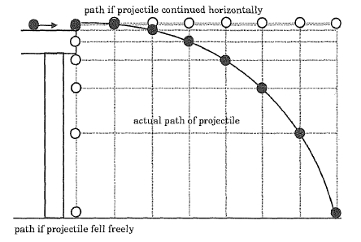
Horizontal velocity is _______________, because_________________________________

Vertical velocity is __________________, because__________________________________

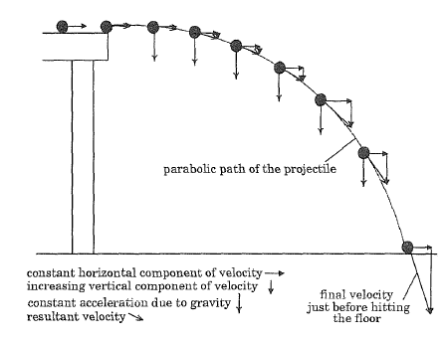
The path travelled can be seen as the sum of vertical and horizontal vectors.
The velocity at any time is the vector sum of the horizontal and vertical vectors.

v_{H} = horizontal velocity v_{V} = vertical velocity
$v_{H}=v\cos{θ}$ $v_{V}=v\sin{θ}$

To avoid confusion with multiple v, these are often referred to as the x and y components

- A ball is thrown at 25ms⁻¹ at an angle of 30°. Calculate the horizontal and vertical velocity components

- Find the velocity of a ball with vertical component of 20ms⁻¹ and horizontal component of 6ms⁻¹.

Time
The time a projectile is in the air depends only on the __________________________________

Range
The range is the horizontal distance a projectile travels from its starting point until it reaches the ground or some obstacle.
As seen before the horizontal velocity is constant.
Therefore the range is calculated by s = v t
(Note that this is simply $\vec{s}={\vec{v}}_{0}t+\frac{1}{2}\vec{a}t^{2}$ where a = 0)

Velocity at any point is time
The velocity at any point in time is the vector sum of the horizontal and vertical vectors.
Remember that the horizontal component is ________________
The vertical component will vary due to gravity and must be calculated

- A marble is travelling at 2.0 ms⁻¹ along a table top. The top of the table is 1.5 m above the floor. Find:
  - The time the marble will take to reach the floor

  - The distance from the table that the marble will land

  - The velocity of the marble just before it reaches the floor (magnitude and direction)

Projectiles with initial velocity at an angle to the horizontal
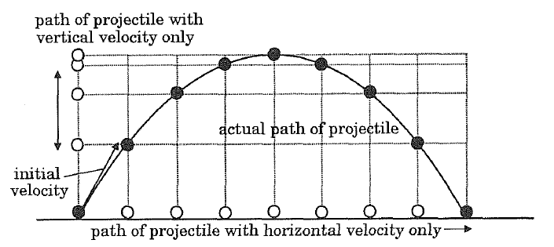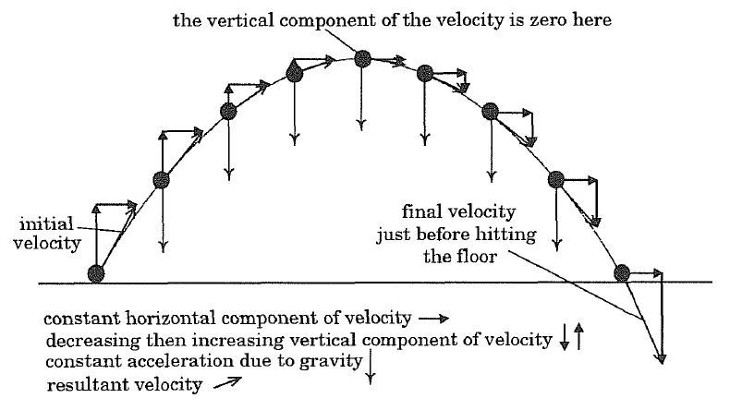
While the projectile is rising, the vertical component decreases to zero at maximum height, then increases again as the projectile falls.

For symmetrical trajectories, the easiest way to find the time is to either find the time from the top (____ = 0), or the time to the top (_____ = 0) then double it.
It is also important to consider direction. As a projectile is moving upwards, acceleration is downwards, ie a is negative
Generally up is positive, down is negative.
- A golf ball is given a speed of 53 ms⁻¹ at an angle of 32° above the horizontal. Find:
  - The time it is in the air

  - Its range

  - Its velocity after 1.5 seconds

- A child lying on the ground fires a water pistol at a friend. The water leaves the water pistol with a speed of 5.0 ms⁻¹ at an angle of 65° above the ground. As the water is rising it hits the friend in the chest 83 cm above the ground. How far away is the friend?

Relationship between ground level launch angle and range
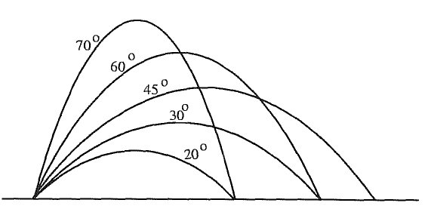
As the launch angle increase the initial vertical component ___________________,
but the initial horizontal component _______________________

The maximum range is found at 45°. Ranges for other angles are symmetrical around this point. Ie the range of 40° and 50° is identical, as are the ranges for 30° and 60°.

Bi level projectiles
- A cricket ball is hit at a height of 1.2 m, giving it a speed of 35 ms⁻¹ at an angle of 50° above the horizontal. How far will the ball travel from the batsmen?

Effect of air resistance: horizontal and vertical components of velocity
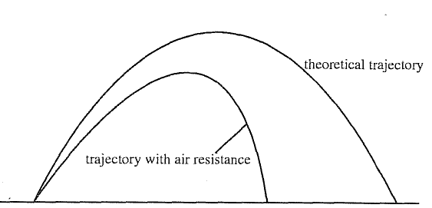
Air resistance will oppose the vertical velocity of a projectile
Therefore the projectile will reach zero vertical velocity sooner
When falling, it will oppose gravitational acceleration, thereby increasing the time taken to fall
Overall the time of flight is slightly decreased.

Air resistance will oppose the horizontal velocity of a projectile, decreasing it throughout the flight
Range depends on horizontal velocity so it will be decreased.

The effect of air resistance: variables
The larger the projected area of an object the more air resistance it experiences. Fewer air particles coming in contact leads to lowered frictional force.
Overall shape and surface texture also effects how easily air moves over the surface.
The faster an object moves the more air resistance it experiences.
The more dense the air, the more air particles will come in contact with the projected surface.

Projectiles in Sport: Range
“Describe and explain the effect of the launch height of a projectile on the maximum range and the effect of the launch angle for a given height”
With launch height h = 0° the max range is achieved with a launch angle of ________
With launch height h > 0° the max range is achieved with a launch angle __________
The greater the launch height, the smaller the angle necessary to achieve maximum range

Projectiles in Sport: Air Resistance
“Investigate the extent to which air resistance affects various projectiles in sport”
Air resistance will affect different projectiles to different extents
Heavier projectiles are affected to a lesser extent than lighter projectiles of the same size
Larger projectiles are affected to a greater extent than smaller projectiles

