Nuclear Fission and Fusion

Spontaneous and induced nuclear fission
Previously we have studied spontaneous fission, the process by which very heavy nuclei split into two smaller nuclei, releasing energy in the MeV range. Some atoms, such as uranium-235, uranium-233 and plutonium-239, can also be forced to undergo nuclear fission by the absorption of slow neutrons. Since the neutrons have no charge, they can enter a nucleus without any coulombic repulsion.
Generally, a number of neutrons as well as gamma photons are emitted. The kinetic energy of the neutrons and smaller nuclei is converted to heat, which can then be converted to electricity in a nuclear power station.
For example, consider the fission reactions of uranium:
$${}_{0}^{1}n+{}_{92}^{235}U→{}_{56}^{141}{Ba}+{}_{36}^{92}{Kr}+3{}_{0}^{1}n+γ \\ {}_{0}^{1}n+{}_{92}^{235}U→{}_{54}^{140}{Xe}+{}_{38}^{94}{Sr}+2{}_{0}^{1}n+γ \\ {}_{0}^{1}n+{}_{92}^{235}U→{}_{50}^{132}{Sn}+{}_{42}^{101}{Mo}+3{}_{0}^{1}n+γ$$
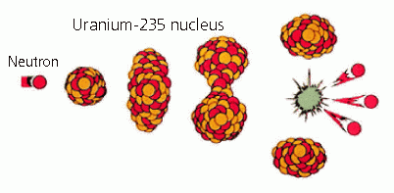
There are a variety of possible pathways and we cannot predict the fission products of any one nucleus. Usually, the fission fragments are unstable isotopes which will radioactively decay. Since the nuclei that can readily undergo fission are particularly neutron-rich, the initial fission products are almost always more neutron-rich than stable nuclei of the same mass number. Due to being relatively neutron-rich for their atomic number, the products often undergo beta decay.
Figure: Spontaneous fission of Uranium-235

How does fission occur
When the neutron enters the nucleus, it can have the effect of distorting the shape of the nucleus. It can also increase the vibrational energy of the nucleus causing it to vibrate in an elongated way. When this occurs, it may not be possible for the short-ranged nuclear force to overcome the longer ranged columbic repulsion due to the increased distance. If the equilibrium shape cannot be restored, then fission occurs and the nucleus is forced apart into two roughly equal parts. Due to the fission mechanism, the mass fragments produced are not always the same.

- Calculate the energy released when the following nuclear fission reaction occurs:
$${}_{0}^{1}n+{}_{92}^{235}U→{}_{56}^{141}{Ba}+{}_{36}^{92}{Kr}+3{}_{0}^{1}n+γ$$
Give your answer in MeV. Masses are: ${}_{0}^{1}n:1.675×{10}^{-27}kg; {}_{92}^{235}{U:3.9017×{10}^{-25};}$$${}_{56}^{141}{Ba:2.28922×{10}^{-25}kg;} {}_{36}^{92}{Kr=1.57534×{10}^{-25}kg}.$$
205 MeV

- Compare the energy released in the above fission reaction with the energies released in a chemical reaction:
Hydrocarbon | Heat given out (kJ per mole) | Heat given out (eV per molecule)
Methane | 889
Octane | 5512
Carbon | 393
Ethanol | 1368
Note that 1 mole equals $6×{10}^{23}$ molecules.

Which reaction gives the most energy and by roughly how much?

Explain how the relative energy of the photons emitted in fission processes and chemical processes correspond to the energy released by the reactions.

- Explain why the nuclei produced by fission reactions are likely to have an excess of neutrons, and identify the type of radioactive decay they undergo.

- Explain why the fission products are hazardous and difficult to process.

Chain reaction
The release of neutrons in spontaneous fission can be used to cause other fissions in a chain reaction. In a chain reaction, the products of the reaction initiate further reactions.
Fission chains result in a continuous production of heat, which is important in energy production in power plants. Up to 5 neutrons can be ejected in the fission of uranium-235, with an average of 2.4 produced. In order to have a sustained chain reaction, at least one neutron per fission must induce another fission.
In order to induce fission, the incoming electron must be slow, about 0.03 eV. However, the neutrons ejected in fission typically have energies of the order 1-2 MeV. Fast neutrons result in less desirable reactions occurring, such as:
- The ejection of a photon
- The ejection of an alpha particle
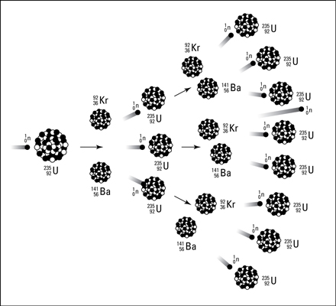
Neither of these reactions produce much energy compared to the fission of a uranium-235.
Figure: Chain reaction schematic

Moderators
Moderators slow down neutrons by collisions. Collisions with the neutrons dissipate the kinetic energy of the neutrons and transfers energy to the moderator.
Moderators need to be low mass nuclei, so that kinetic energy can be transferred from the neutron to the moderator.
Hydrogen atoms ${}_{}^{1}H$ in water molecules would be ideal, except that the ${}_{}^{1}H$ atoms absorb neutrons to form the isotopes ${}_{}^{2}H$and ${}_{}^{3}H$. The most effective moderator is deuterium, ${}_{}^{2}H$. Deuterium is found in `heavy water’. Each collision with the ${}_{}^{2}H$ atoms transfers 10-20% of the neutron’s kinetic energy to the moderator nuclei.
Carbon is another commonly used moderator. However, it is not as effective as deuterium due to its larger mass. It takes roughly 120 collisions with the carbon atoms before the neutron has lost enough energy to promote fission.

Enrichment
The majority of the uranium fuel used in the reactor is the uranium-238 isotope. Another consequence of the moderation of the energies of the neutrons is that slow neutrons minimise the absorption of the neutrons by the uranium-238 isotope:
$${}_{0}^{1}n+{}_{92}^{238}U→{}_{92}^{239}U+γ$$
In fact, many of the neutrons will be absorbed by surrounding nuclei or escape, which does not help in maintaining a sustained chain reaction.
To overcome this:
- The `core reaction’ is covered with a reflector blanket to reflect the slow neutrons back into the core.
- The mass of the fuel needs to be able to maintain the chain reaction, also called the critical mass.
Naturally occurring uranium does not have enough uranium-235 to maintain a chain reaction; too many of the neutrons would be removed by other factors. The natural ore has to be enriched to increase the percentage of uranium-235, the increase is typically between 2 and 4%. The isotopes are chemically equivalent, but they can be separated using their different masses.

- Explain why neutrons have to be slowed down in order to produce fission in ${}_{92}^{235}U$.

- Explain why the most effective moderators have:
  - atoms of low mass

  - low absorption of neutrons.

- Explain why it is generally not possible to attain a continuous chain reaction using naturally occurring uranium unless it is enriched with ${}_{92}^{235}U$.

Application: Fission nuclear power
A nuclear reactor is designed for starting and controlling a self-sustaining fission chain reaction. Thermal reactors use slow neutrons to generate energy. We will consider a water moderated power reactor.
The basic parts of a nuclear reactor are:
- Core – fuel rods with made out of uranium or uranium oxide coated with a metallic alloy.
- A neutron moderator – slows down the neutrons emitted.
- Control rods – made of neutron absorbers to regulate the population of neutrons and hence the reactions.
- Safety rods – similar to the control rods, except these rods contain enough absorber to terminate a chain reaction under any conceivable condition.
- Radiation shielding – stops the radiation emitted, made up of two types:
  - A thermal shield made of temperature resistant metal to protect the outer shield from heat.
  - An outer biological shield made of very thick concrete (5m) to stop gamma radiation.
- A coolant – absorbs the heat from the reaction and carries it away to heat exchanger.
- Heat exchanger – heat is transferred from coolant to other water in the heat exchanger which then boils and powers a turbine.

The control system – the control rods
Nuclear reactions can be controlled by the number of neutrons in the neutron flux. To do this, elements that are effective absorbers of neutrons, such as boron and cadmium can be used. The control substances are usually made into rods that can be inserted between the fuel rods.

If the reactor is required to produce more energy, the rods are pulled out to allow more neutrons to access the fuel and increase the number of fission reactions. The reactor can be stopped by inserting the control rods and the safety rods fully into the core, absorbing all of the neutrons.

Delayed emission of neutrons
Neutrons emitted in nuclear reactions exist for a very short time before they trigger another reaction, escape or are absorbed. Most fission reactions emit two or three neutrons, so the reaction could grow out of control very quickly due to the chain reaction mechanism. However, about 1% of the neutrons in a reactor core come from delayed emission. These neutrons come from the decay of the daughters of the fission reaction and can be up to 10 seconds delayed.

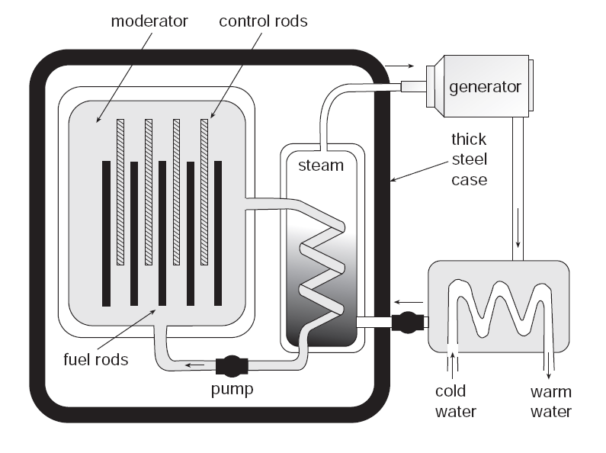
One of the safety factors built into the nuclear reactors which are used for electricity generation is that they are only critical with the inclusion of the delayed neutrons which are emitted by some of the fission fragments. The neutron population of the core is maintained such that the delayed neutrons are required to sustain the chain reaction. This way the doubling time of the reaction is significantly increased. This allows time for the control rod mechanism to react.
Figure: Pressurized water reactor

How do reactors work?
- Fuel rods are loaded into the core with the control rods in place.
- Safety rods are removed.
- Control rods are partially withdrawn.
- Neutrons are able to undergo fission.
- Control rod adjusting system monitors the number of neutrons in the system.
- Once the reactor is `critical’, that is self-sustaining, the rods are continually adjusted to maintain the steady state.

Advantages and disadvantages of fission over fossil fuels
Advantages:
- Zero carbon emissions.
- No toxic emissions of carbon monoxide, sulfur oxide and nitrogen oxides.
- Large amounts of energy for a small amount of fuel.
Disadvantages:
- Thermal pollution from heat exchanger warming up water.
- Disposal of spent fuel rods which are radioactive.
- Decommissioning of nuclear power stations.
- Potential for accidents.
- Threat of nuclear weapons.

- Describe and discuss the function of the principal components of a water-moderated fission power reactor (core, fuel rods, moderator, control rods, safety rods, heat exchanger and shielding).

- How is the chain reaction initiated in the nuclear reactor?

- How is the chain reaction stopped?

- Explain briefly why the delayed emission of neutrons allows the chain reaction in a nuclear power reactor to be controlled.

- Discuss some of the advantages and disadvantages of nuclear fission over fossil fuel power stations.

Nuclear Fusion
In contrast to nuclear fission, fusion involves the joining together of two small nuclei to form a large, more stable one. The major source of energy in the universe comes from nuclear fusion reactions. Generally, more energy is released in fusion than fission. For example, the sun generates its energy from nuclear fusion.
In order for fusion to occur, high kinetic energies are needed to overcome the repulsive electrostatic force between the nuclei and to allow the nuclei to approach within the very short range of the nuclear-attractive forces. Nuclear fusion takes place in a gaseous phase, and nuclei with the required kinetic energy need to be at a temperature of about 100 million °C.

A typical fusion reaction involving deuterium, ${}_{1}^{2}H$, and tritium, ${}_{1}^{3}H$, is:
$${}_{1}^{2}H+{}_{1}^{3}H→{}_{2}^{4}{He}+{}_{0}^{1}{n. (17.6 MeV)}$$
Other fusion reactions are:
$${}_{1}^{2}H+{}_{1}^{2}H→{}_{2}^{3}{He}+{}_{0}^{1}{n,} (3.2 MeV) \\ {}_{1}^{2}H+{}_{1}^{3}H→{}_{1}^{3}H+{}_{1}^{1}{H.} (4.0 MeV)$$
Notice that the first reaction releases much more energy. This is because the products in the second and third reaction do not have the binding energy and hence stability of the helium nucleus.
In fact, when a helium nucleus is formed in a fusion reaction, a large amount of energy is always released. For example,
$${}_{1}^{2}H+{}_{2}^{3}{He}→{}_{2}^{4}{He}+{}_{1}^{1}{H (18.3 MeV)}.$$
Again, we can compare the energies released with the energy released in chemical reaction. Typically nuclear fusion provides ${10}^{7}$ times more energy per mass.
Deuterium, ${}_{1}^{2}H$, features in many of our fusion reactions because those reactions have the highest probabilities of fusion at the lowest energies. However other reactions involving heavier elements are possible.

The sun and other stars as nuclear fusion reactors
The internal temperature of the sun’s core is about 20 million °C, lower than required for fusion. However, the protons in the Sun are racing around at a range of velocities according to the temperature. While the typical velocity is far too small to defeat the Coulomb barrier, some electrons on the tail of the velocity distribution curve do have enough energy.
The reaction pathway thought to occur in the sun is:
$${}_{1}^{1}H+{}_{1}^{1}H→{}_{1}^{2}H+{}_{+1}^{0}e+ν \\ {}_{1}^{1}H+{}_{1}^{2}H→{}_{2}^{3}H+γ \\ {}_{2}^{3}{He}+{}_{2}^{3}{He→{}_{2}^{4}He+{}_{1}^{1}H+{}_{1}^{1}H}.$$
Notes:
- Two protons are produced, which can continue the cycle
- At such high temperatures the gases in the sun are in the form of ions, called a plasma. The gravitational attraction of the sun holds the plasma together, ensuring that the density is high enough to allow for a high rate of particle collision.
- The alpha particles produced have very large kinetic energies, which is quickly transferred back into smaller nuclei through collisions, since the alpha particles are charged and relatively large.

Advantages and disadvantages of fusion over fission as a power source
Advantages:
- The fuel, deuterium, is found in water in almost inexhaustible amounts, about $4.5× {10}^{16} kg$ is in the sea. At present consumption, this would last about 1 billion years.
- The waste products are generally not radioactive.
- No greenhouse gas emissions.
- Safer to operate as only a few grams of fuel are present in the plasma vessel at a time and there is no chain reaction to control.

Disadvantages:
- No net production of energy at this point in time.
- Billions of dollars of research funding required to develop.

 | Nuclear Fission | Nuclear Fusion
Definition: | Fission is the splitting of a large atom into two or more smaller ones. | Fusion is the fusing of two or more lighter atoms into a larger one.
Natural occurrence of the process: | Fission reaction does not normally occur in nature. | Fusion occurs in stars, such as the sun.
By-products of the reaction: | Fission produces many highly radioactive particles. | Few radioactive particles are produced by fusion reaction, but if a fission "trigger" is used, radioactive particles will result from that.
Conditions: | Critical mass of the substance and slow neutrons are required. | High density, high temperature environment is required.
Energy Requirement: | Takes little energy to split two atoms in a fission reaction. | Extremely high energy is required to bring two or more protons close enough that nuclear forces overcome their electrostatic repulsion.
Energy Released: | The energy released by fission is a million times greater than that released in chemical reactions; but lower than the energy released by nuclear fusion. | The energy released by fusion is three to four times greater than the energy released by fission.
Nuclear weapon: | One class of nuclear weapon is a fission bomb, also known as an atomic bomb or atom bomb. | One class of nuclear weapon is the hydrogen bomb, which uses a fission reaction to "trigger" a fusion reaction.

- Calculate the energy emitted when the following fusion reaction occurs in J and MeV:
$${}_{1}^{3}H+{}_{1}^{3}H→{}_{2}^{4}{He}+2 {}_{0}^{1}{n.}$$
Masses are: ${}_{0}^{1}n:1.675×{10}^{-27}kg; {}_{1}^{3}{H:5.0080×{10}^{-27};}$$${}_{1}^{2}{H:3.3445×{10}^{-27}kg;} {}_{2}^{4}{He=6.644×{10}^{-27}kg}.$$

- Describe how the conditions in the interiors of the Sun and other stars allow nuclear fusion to take place.

- Discuss the advantages and disadvantages of nuclear fusion over nuclear fission as a future source of power.

