**STAGE 2 PHYSICS**

### READING

Key Ideas pg 35-50

**Motion in 2 Dimensions**

**Forces Causing Centripetal Acceleration**

|  |  |
| --- | --- |
| **Force Causing the Centripetal Acceleration** |  |
| A net force directed towards the centre of the circle is necessary to produce the centripetal acceleration. | Describe situations in which the centripetal acceleration is caused by a tension force, a frictional force, a gravitational force, or a normal force. |
| **Application: The Banking of Road Curves** |  |
|  | Identify the vertical and horizontal forces on a vehicle moving with constant velocity on a flat horizontal road. |
|  | Explain that when a vehicle travels round a banked curve at the correct speed for the banking angle, the horizontal component of the normal force on the vehicle (not the frictional force on the tyres) causes the centripetal acceleration. |
|  | Derive the equation  relating the banking angle  to the speed  of the vehicle and the radius of curvature |
|  | Solve problems involving the use of the equation |

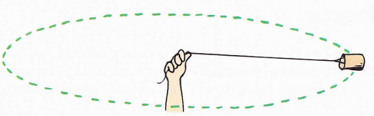

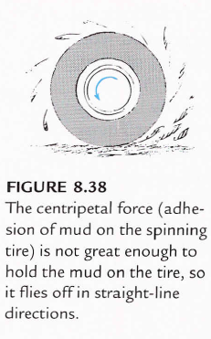**Forces Producing Centripetal Acceleration**

Any net force, which is acting at right angles to the velocity of an object, will produce centripetal acceleration and therefore cause the object to follow a circular path.

The force producing centripetal acceleration is often called **centripetal force.**

Like centripetal acceleration, centripetal force always acts towards the centre of the circle.

**Deriving the formula for Centripetal Force**

Note: Not a required derivation, however it is not given on the formula sheet!

**Tensile Force**

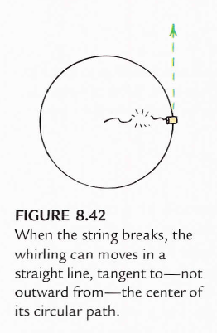In the case of the stone whirled around on the string, the force which is continually pulling the stone towards the centre is the tension. If the string broke suddenly, the stone would fly off in the direction of its velocity at that instant, i.e. Its *linear*, or *tangential*, velocity.

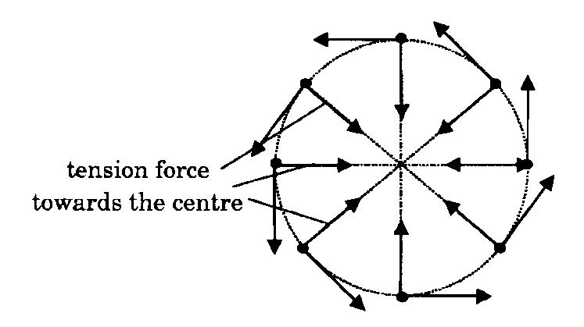

**Gravitational Force**

The moon and artificial satellites travel around the earth and the planets travel around the sun because the force of gravity acts as a force producing centripetal acceleration

**Application: Banked Curves**

**Frictional Force**

A car is able to move on a road because of the friction force between its tyres and the road surface. If there was no friction, the tyres would simple slip on the surface and the car would not be able to move.

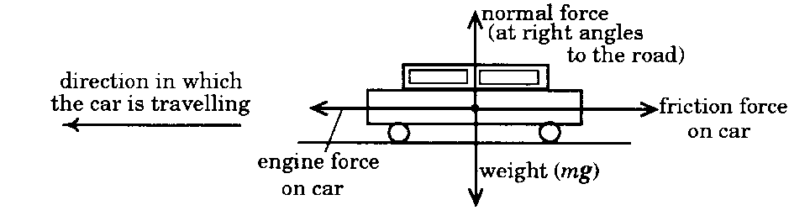

**Forces acting on car**

A car on a road has a number of forces acting on it:

* the force of the engine pushing forwards
* friction pushing back
* the car's weight pushing down
* a normal force pushing up, as required by Newton's Third Law.

**Normal Force**

The **normal force** is always at right angles to the road surface and is only equal and opposite to the car's weight when it is on a flat road.

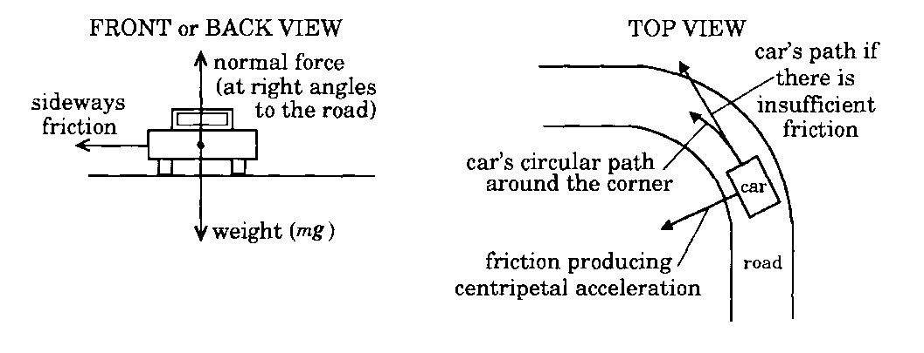When the car is travelling with **constant speed** in a straight line all these forces are balanced and the net force is zero.

**Sideways Friction**

When the car is turning the corner it is travelling around part of a circle, and therefore there must be a force acting on the car to produce centripetal acceleration.

This force is the **sideways friction** between the car's tyres and the road.

This is not a balanced force and changes the car's direction.

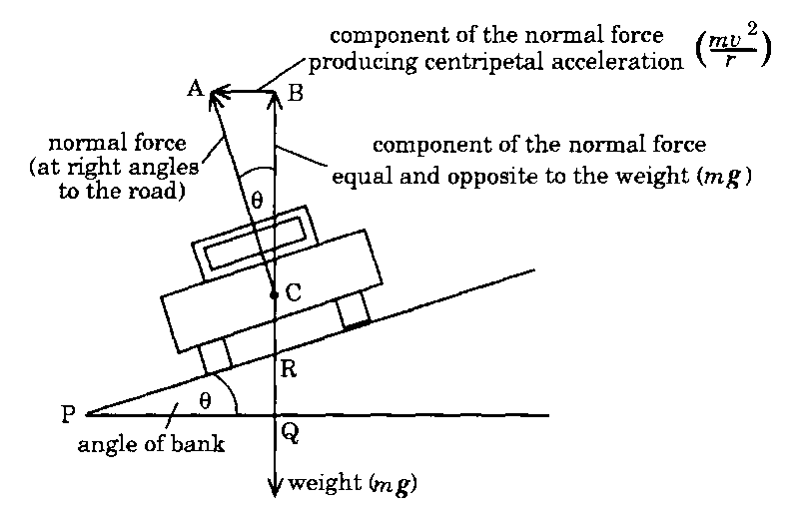**Normal Force on Banked Roads**

In many situations a curving road can be made safer by building it at an angle.

The road is said to be banked and in this situation the normal force to the road surface provides additional centripetal acceleration

As the diagram shows, the normal force can be resolved into two components, one vertical, and the other horizontal.

* The vertical component is equal but opposite to the weight of the car.
* The horizontal component produces a force at right angles to the car's direction of motion, towards **the centre of the circle** made by the road.
* This component of the normal force is the force producing the centripetal acceleration.

**Derivation of the banking equation \*\**required derivation*\*\***

**Sample Question**

1. A road has speed limit of 70 km per hour. What banking angle is required for a curve of radius 400 m, which will allow vehicles to travel around the curve at 70 km per hour without relying on friction?
2. What centripetal acceleration will a car experience travelling at this speed around the curve?