**VERIFICATION FORM**

Student’s name ----------------------------------------------------------------------

address --------------------------------------------------------------------

-------------------------------------------Postcode--------------

|  |  |
| --- | --- |
| Subject Teacher To complete all test details. Test Supervisor to complete Test supervisor details, sign the verification form and return to subject teacher with test materials. | Teacher’s Name Jan Menzies  Subject Physics – SAT 4: Light and Matter  Date of test... On or before Friday 27th July.  **Test Duration... 1 hour 15 mins**  **Additional Information...**  **Students are advised to have a calculator, ruler, and pencil available for this test.**  **The equation sheet is at the end of the test equation sheet.**  **DECLARATION**  I declare that the test outlined on this form was conducted under the conditions specified by the guidelines and the teacher ie. That:   * **All work included is that of the student(s) whose name(s) appear on this form,** * **No assistance was received by the student(s) in the completion of this test, and** * **The test was completed within the specified time limit** * **Additional teacher specified conditions...**   **Test Supervisor’s**  **Printed name ……………………………………….**  **Signature ………………………………………. Date ………………..** |
|  |  |

|  |  |  |
| --- | --- | --- |
| A | Applies physics concepts and evidence from investigations to suggest solutions to complex problems in new and familiar contexts.  Uses appropriate physics terms, conventions, formulae, and equations highly effectively.  Demonstrates initiative in applying constructive and focused individual and collaborative work skills. | Consistently demonstrates a deep and broad knowledge and understanding of a range of physics concepts.  Uses knowledge of physics perceptively and logically to understand and explain contemporary applications.  Uses a variety of formats to communicate knowledge and understanding of physics coherently and highly effectively. |
| B | Applies physics concepts and evidence from investigations to suggest solutions to problems in new and familiar contexts.  Uses appropriate physics terms, conventions, formulae, and equations effectively.  Applies mostly constructive and focused individual and collaborative work skills. | Demonstrates some depth and breadth of knowledge and understanding of a range of physics concepts.  Uses knowledge of physics logically to understand and explain contemporary applications.  Uses a variety of formats to communicate knowledge and understanding of physics coherently and effectively. |
| C | Applies physics concepts and evidence from investigations to suggest some solutions to basic problems in new or familiar contexts.  Uses generally appropriate physics terms, conventions, formulae, and equations with some general effectiveness.  Applies generally constructive individual and collaborative work skills. | Demonstrates knowledge and understanding of a general range of physics concepts.  Uses knowledge of physics with some logic to understand and explain one or more contemporary applications.  Uses different formats to communicate knowledge and understanding of physics with some general effectiveness. |
| D | Applies some evidence to describe some basic problems and identify one or more simple solutions, in familiar contexts.  Attempts to use some physics terms, conventions, formulae, and equations that may be appropriate.  Attempts individual work inconsistently, and contributes superficially to aspects of collaborative work. | Demonstrates some basic knowledge and partial understanding of physics concepts.  Identifies and explains some physics information that is relevant to one or more contemporary applications.  Communicates basic information to others using one or more formats. |
| E | Identifies a basic problem and attempts to identify a solution in a familiar context.  Uses some physics terms or formulae.  Shows emerging skills in individual and collaborative work. | Demonstrates some limited recognition and awareness of physics concepts.  Shows an emerging understanding that some physics information is relevant to contemporary applications.  Attempts to communicate information about physics. |

1. In the 17 30’s Faraday investigated changing magnetic fields and observed an electric current created in a conductor.
2. Describe with the support of a diagram what is present in the region surrounding a charged particle?

_____________________________________________________________________________________________________________________________________________________________________________________________________________________________________________________________________________________________________________________________________________________________________________ [2]

1. What must be present associated with the current induced by a changing magnetic field?

____________________________________________________________________________________[1]

1. In thinking about Faradays findings Maxwell made an assumption about the symmetry of nature. What did he assume?

____________________________________________________________________________________________

___________________________________________________________________________________________________________________________________________________________________________________[1]

1. In the 17th century light was observed to travel in straight lines and particle theory was consistent with the measurements of reflection and refraction. Calculations of the speed of light showed it travelled at 3x108 ms-1
2. Refer to the diagram provided, to explain the creation of an electro-magnetic wave.

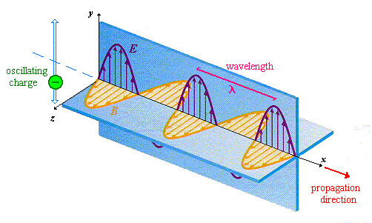

_________________________________________________________________________________________________________________________________________________________________________________________________________________________________________________________________________________________________________________________________________________________________________________________________________________________________________________________________________________________________________________________________________________________________________________________________________________________________________________________________________________________________________________________________________________________________________________________________________________________________________________________________________________________________________________________________________________________________________________________________________________________________________________________________________________________________________________________________________________________________________________________________________________________________________________________________________________________________________________________________________________________________________________________________________________________________[6]

1. Mathematical calculations predicted this electro-magnetic wave would propagate at 3x108 ms-1 . What did this suggest about the nature of visible light and what observations would support this?

________________________________________________________________________________________________________________________________________________________________________________________________________________________________________________________________________________________________________________________________________________________________________________________________________________________________________________________________________[2]

1. Calculate the frequency of radio waves which have a wavelength of 240cm.

________________________________________________________________________________________________________________________________________________________________________________________[1]

1. Explain why it is possible to improve the reception of an old TV (analogue) by adjusting the orientation of the internal antennae.

________________________________________________________________________________________________________________________________________________________________________________________________________________________________________________________________________________[1]

1. A compact Disk player reads the surface using a laser beam. The tracks on a CD contain bumps and lands. As the laser is reflected from these surfaces the signal intensity changes.

Consider a CD where the bumps on the track have a height of 135nm and are read by a laser with wavelength 520 nm

1. Draw a labelled diagram showing a beam reflecting off a bump and a beam reflecting off the flat. Identify key information.

|  |  |  |  |  |  |  |  |  |  |  |  |  |  |  |  |  |  |  |  |  |  |  |  |  |  |  |  |  |  |  |  |  |  |
| --- | --- | --- | --- | --- | --- | --- | --- | --- | --- | --- | --- | --- | --- | --- | --- | --- | --- | --- | --- | --- | --- | --- | --- | --- | --- | --- | --- | --- | --- | --- | --- | --- | --- |
|  |  |  |  |  |  |  |  |  |  |  |  |  |  |  |  |  |  |  |  |  |  |  |  |  |  |  |  |  |  |  |  |  |  |
|  |  |  |  |  |  |  |  |  |  |  |  |  |  |  |  |  |  |  |  |  |  |  |  |  |  |  |  |  |  |  |  |  |  |
|  |  |  |  |  |  |  |  |  |  |  |  |  |  |  |  |  |  |  |  |  |  |  |  |  |  |  |  |  |  |  |  |  |  |
|  |  |  |  |  |  |  |  |  |  |  |  |  |  |  |  |  |  |  |  |  |  |  |  |  |  |  |  |  |  |  |  |  |  |
|  |  |  |  |  |  |  |  |  |  |  |  |  |  |  |  |  |  |  |  |  |  |  |  |  |  |  |  |  |  |  |  |  |  |
|  |  |  |  |  |  |  |  |  |  |  |  |  |  |  |  |  |  |  |  |  |  |  |  |  |  |  |  |  |  |  |  |  |  |
|  |  |  |  |  |  |  |  |  |  |  |  |  |  |  |  |  |  |  |  |  |  |  |  |  |  |  |  |  |  |  |  |  |  |
|  |  |  |  |  |  |  |  |  |  |  |  |  |  |  |  |  |  |  |  |  |  |  |  |  |  |  |  |  |  |  |  |  |  |

[2]

1. By comparing the path difference between the two beams, with the wavelength of the laser, explain why light reflected from a bump and a flat surface interferes to produce a beam of reduced intensity.

_________________________________________________________________________________________________________________________________________________________________________________________________________________________________________________________________________________________________________________________________________________________________________________________________________________________________________________________________________[2]

1. A diathermy machine, used in physiotherapy to hasten the repair of soft tissue damage, generates e-m radiation that gives the effect of deep heat. If the machine generates waves with frequency 15.6MHz
   1. What is the wavelength of this electromagnetic wave?
   2. Would machine operators need to take safety precautions to protect themselves from these rays?

__________________________________________________________________________________________________________________________________________________________________________________________________________________________________________________________________________________________________________________________________________________________________________________________________________________________________________________________________________[2]

1. In a young’s double slit experiment, the double slits are illuminated with light containing 2 wavelengths. One of the wavelengths is 580nm while the other is unknown. The fourth bright fringe of the 580nm radiation coincides with the sixth dark fringe for the unknown wavelength. Determine the unknown wavelength.

______________________________________________________________________________________________________________________________________________________________________________________________________________________________________________________________________________________________________________________________________________________________________________________________________________________________________________________________________________________________________________________________________________________________________________________________________________________________________[3]

1. Find the wavelength of three lines in the spectrum of hydrogen, given that these lines reinforce in the first order at angles of 20.68o, 20.07o and 16.93o from the normal to the grating. Base your calculations on the fact that the mercury 2nd order green line of wavelength 54.1 nm is seen at 40.2o

____________________________________________________________________________________________________________________________________________________________________________________________________________________________________________________________________________________________________________________________________________________________________________________________________________________________________________________________________________________________________________________________________________________________________________________________________________________________________________________________________________________________________________________________________________________________________________________________________________________________________________________________________________________________________________________________________________________________________________________________________[4]

1. A 5.6 x 1014 Hz laser beam is directed onto two slits as shown below.
   1. Mark on the screen in the diagram below, an indication of the band width for 2 orders above and below the central order.

[1]

* 1. Using the positions shown from part a sketch an intensity graph along the screen. Clearly indicate the centre of the pattern.

[1]

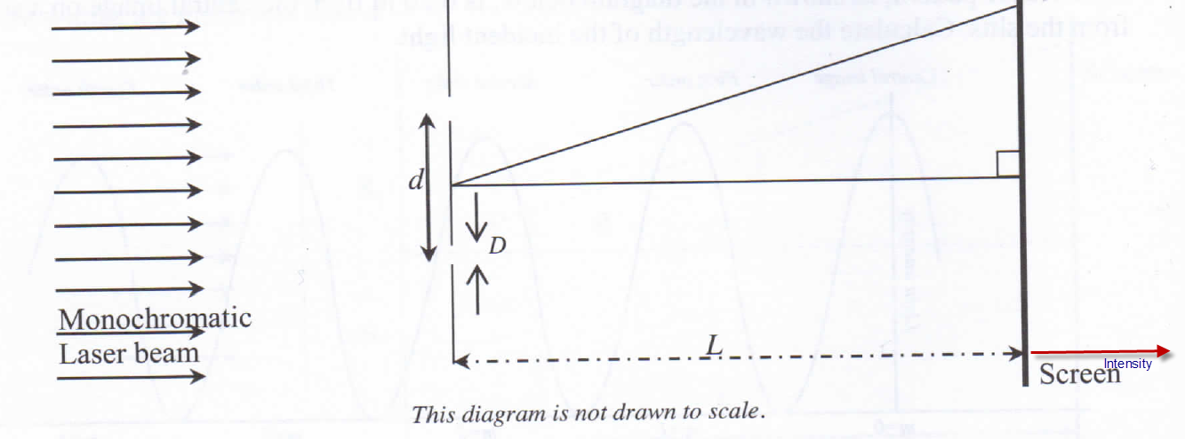

* 1. To produce an interference pattern, the light incident on the slits must be in a constant phase relationship.
     1. Explain the phrase *constant phase relationship*

_________________________________________________________________________________________________________________________________________________________________________________________________________________________________________________________________________________________________________________________________________________________________________________________[2]

* + 1. In the diagram above, a coherent light source is from the laser, outline an alternative method for producing coherent light, from a non-coherent source to illuminate the slits.

_____________________________________________________________________________________________________________________________________________________________________________________________________________________________________________________________________________________________________________________________________________________________________________________________________________________________________________________________________________________________________________________________________________________________________________________________________________________________________________________________________________________________________________________________________________________________________________________[3]

* 1. Describe quantitatively how the interference pattern with fringe width of 1.2 x 10-4 m changes if the distance d between the slits is reduced by a third.

______________________________________________________________________________________________________________________________________________________________________________________________________________________________________________________________________________________________________________________________________________________________________________________[1]

1. The graph below shows the measured angular positions $∅$ of the interference maxima for a transmission grating, plotted as a function of the order, n of the maximum.

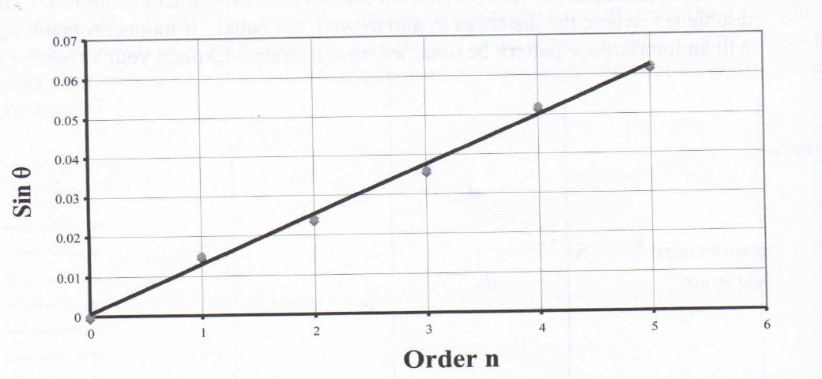

Use the graph to determine the wavelength of light given that the grating was 25 lines per mm.

_____________________________________________________________________________________________________________________________________________________________________________________________________________________________________________________________________________________________________________________________________________________________________________________________________________________________________________________________________________________________________________________________________________________________________________________________________________________________________________________________________________________________________________________________________________________________________________________________________________________________________________________________________________________[4]

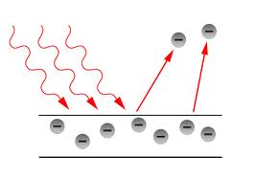

(extended answer question)

1. Describe the characteristics of the photoelectric effect and how the concept of a photon is important in explaining these effects.

__________________________________________________________________________________________________________________________________________________________________________________________________________________________________________________________________________________________________________________________________________________________________________________________________________________________________________________________________________________________________________________________________________________________________________________________________________________________________________________________________________________________________________________________________________________________________________________________________________________________________________________________________________________________________________________________________________________________________________________________________________________________________________________________________________________________________________________________________________________________________________________________________________________________________________________________________________________________________________________________________________________________________________________________________________________________________________________________________________________________________________________________________________________________________________________________________________________________________________________________________________________________________________________________________________________________________________________________________________________________________________________________________________________________________________________________________________________________________________________________________________________________________________________________________________________________________________________________________________________________________________________________________________________________________________________________________________________________________________________________________________________________________________________________________________________________________________________________________________________________________________________________________________________________________[8]

1. The photoelectric work function for sodium is 2.3eV
   1. Calculate the threshold wavelength of incident light for this metal
   2. Explain whether light of wavelength 580 nm would cause the emission of a photoelectron
   3. Light of wavelength 350nm illuminates the sodium surface: calculate the range of kinetic energies with which electrons are ejected.

____________________________________________________________________________________________________________________________________________________________________________________________________________________________________________________________________________________________________________________________________________________________________________________________________________________________________________________________________________________________________________________________________________________________________________________________________________________________________________________________________________________________________________________________________________________________________________________________________________________________________________________________________________________________________________________________________________________________________________________________________________________________________________________________________________________________________________________________________________________________________________________________________________________________________________________________________________________________________________________________________________________________________________________________________________________________________________________________________________________________________________________________________________________________________________[5]

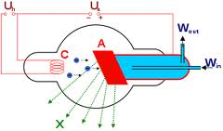

1. What acceleration potential is required to produce X-rays with maximum hardness of 5.77x1018 Hz?

____________________________________________________________________________________________________________________________________________________________________________________________________________________________________________________________________________________________________________________________________________________________________________________________________________________________________________________________________________________________________________________________________________________________________________________________________________________________________________________________________________________[2]

1. a. Calculate the DeBroglie wavelength of an electron moving with a speed of 3x105ms-1.

b. Explain how would you detect this wave length?

________________________________________________________________________________________________________________________________________________________________________________________________________________________________________________________________________________________________________________________________________________________________________________________________________________________________________________________________________________________________________________________________________________________________________________________________________________________________________________________________________________________________________________________________________________________________________________________________________________________________________________________________________________________________________________________________________________________________________________________________________________________________________________________________________________[2]

1. Derive an expression relating kinetic energy to momentum for a particle. Hence sketch a graph of kinetic energy versus momentum

|  |  |  |  |  |  |  |  |  |  |  |  |  |  |  |  |  |  |  |  |  |  |  |  |  |  |  |  |  |  |  |  |  |  |
| --- | --- | --- | --- | --- | --- | --- | --- | --- | --- | --- | --- | --- | --- | --- | --- | --- | --- | --- | --- | --- | --- | --- | --- | --- | --- | --- | --- | --- | --- | --- | --- | --- | --- |
|  |  |  |  |  |  |  |  |  |  |  |  |  |  |  |  |  |  |  |  |  |  |  |  |  |  |  |  |  |  |  |  |  |  |
|  |  |  |  |  |  |  |  |  |  |  |  |  |  |  |  |  |  |  |  |  |  |  |  |  |  |  |  |  |  |  |  |  |  |
|  |  |  |  |  |  |  |  |  |  |  |  |  |  |  |  |  |  |  |  |  |  |  |  |  |  |  |  |  |  |  |  |  |  |
|  |  |  |  |  |  |  |  |  |  |  |  |  |  |  |  |  |  |  |  |  |  |  |  |  |  |  |  |  |  |  |  |  |  |
|  |  |  |  |  |  |  |  |  |  |  |  |  |  |  |  |  |  |  |  |  |  |  |  |  |  |  |  |  |  |  |  |  |  |
|  |  |  |  |  |  |  |  |  |  |  |  |  |  |  |  |  |  |  |  |  |  |  |  |  |  |  |  |  |  |  |  |  |  |
|  |  |  |  |  |  |  |  |  |  |  |  |  |  |  |  |  |  |  |  |  |  |  |  |  |  |  |  |  |  |  |  |  |  |
|  |  |  |  |  |  |  |  |  |  |  |  |  |  |  |  |  |  |  |  |  |  |  |  |  |  |  |  |  |  |  |  |  |  |
|  |  |  |  |  |  |  |  |  |  |  |  |  |  |  |  |  |  |  |  |  |  |  |  |  |  |  |  |  |  |  |  |  |  |
|  |  |  |  |  |  |  |  |  |  |  |  |  |  |  |  |  |  |  |  |  |  |  |  |  |  |  |  |  |  |  |  |  |  |
|  |  |  |  |  |  |  |  |  |  |  |  |  |  |  |  |  |  |  |  |  |  |  |  |  |  |  |  |  |  |  |  |  |  |
|  |  |  |  |  |  |  |  |  |  |  |  |  |  |  |  |  |  |  |  |  |  |  |  |  |  |  |  |  |  |  |  |  |  |
|  |  |  |  |  |  |  |  |  |  |  |  |  |  |  |  |  |  |  |  |  |  |  |  |  |  |  |  |  |  |  |  |  |  |
|  |  |  |  |  |  |  |  |  |  |  |  |  |  |  |  |  |  |  |  |  |  |  |  |  |  |  |  |  |  |  |  |  |  |
|  |  |  |  |  |  |  |  |  |  |  |  |  |  |  |  |  |  |  |  |  |  |  |  |  |  |  |  |  |  |  |  |  |  |
|  |  |  |  |  |  |  |  |  |  |  |  |  |  |  |  |  |  |  |  |  |  |  |  |  |  |  |  |  |  |  |  |  |  |
|  |  |  |  |  |  |  |  |  |  |  |  |  |  |  |  |  |  |  |  |  |  |  |  |  |  |  |  |  |  |  |  |  |  |
|  |  |  |  |  |  |  |  |  |  |  |  |  |  |  |  |  |  |  |  |  |  |  |  |  |  |  |  |  |  |  |  |  |  |
|  |  |  |  |  |  |  |  |  |  |  |  |  |  |  |  |  |  |  |  |  |  |  |  |  |  |  |  |  |  |  |  |  |  |
|  |  |  |  |  |  |  |  |  |  |  |  |  |  |  |  |  |  |  |  |  |  |  |  |  |  |  |  |  |  |  |  |  |  |
|  |  |  |  |  |  |  |  |  |  |  |  |  |  |  |  |  |  |  |  |  |  |  |  |  |  |  |  |  |  |  |  |  |  |
|  |  |  |  |  |  |  |  |  |  |  |  |  |  |  |  |  |  |  |  |  |  |  |  |  |  |  |  |  |  |  |  |  |  |
|  |  |  |  |  |  |  |  |  |  |  |  |  |  |  |  |  |  |  |  |  |  |  |  |  |  |  |  |  |  |  |  |  |  |
|  |  |  |  |  |  |  |  |  |  |  |  |  |  |  |  |  |  |  |  |  |  |  |  |  |  |  |  |  |  |  |  |  |  |
|  |  |  |  |  |  |  |  |  |  |  |  |  |  |  |  |  |  |  |  |  |  |  |  |  |  |  |  |  |  |  |  |  |  |
|  |  |  |  |  |  |  |  |  |  |  |  |  |  |  |  |  |  |  |  |  |  |  |  |  |  |  |  |  |  |  |  |  |  |
|  |  |  |  |  |  |  |  |  |  |  |  |  |  |  |  |  |  |  |  |  |  |  |  |  |  |  |  |  |  |  |  |  |  |
|  |  |  |  |  |  |  |  |  |  |  |  |  |  |  |  |  |  |  |  |  |  |  |  |  |  |  |  |  |  |  |  |  |  |

[4]

# Equation sheet

The following tables show the symbols of common quantities and physical constants used in the equations. Other symbols used are shown next to the equations. Vectors are shown in bold type. If only the magnitude of a vector quantity is used, the symbol is **not** shown in bold type.

## Symbols of common quantities

acceleration **a** charge *q*

time *t* mass *m*

displacement **s** potential difference 

velocity **v** momentum **p**

period *T* electric field **E**

frequency *f* kinetic energy *K*

wavelength  magnetic field **B**

force **F** electric current *I*

## Physical constants

Constant of universal gravitation *G* = 6.67 x 10–11 Nm2 kg–2

Speed of light in a vacuum *c* = 3.00 x 108 ms–1

Coulomb’s law constant  = 9.00 x 109 Nm2 C–2

Planck’s constant *h* = 6.63 x 10–34 Js

Charge of the electron *e* = 1.60 x 10–19 C

Mass of the electron *me* = 9.11 x 10–31 kg

Mass of the proton *mp* = 1.673 x 10–27 kg

Mass of the neutron *mn* = 1.675 x 10–27 kg

Mass of the  particle  = 6.645 x 10–27 kg

## Motion in two dimensions

|  |  |
| --- | --- |
| **v** = **v**0 + **a***t* **v** = velocity at time *t*  **v**0 = velocity at *t* = 0  **s** = **v**0*t* + **a***t*2 v2 = v + 2 as  a =  r = radius of circle  *v* =  *v*H = v cos   = angle to horizontal  *v*v = v sin   = banking angle  tan  = | *v* =  *r* = radius of orbit  *M* = mass of object  orbited by satellite  **F** = *m***a**  **p** = *m***v**  **F** =  **v** =**v**f – **v**i **v**f = final velocity  **v**i = initial velocity  =   = average acceleration  *K* =  *mv*2 |

F = *G* *r* = distance between w = Fs cos  = angle between Force **F**

masses *m*1*m*2

and displacement **S**

*G* = constant of universal

## Electricity and magnetism

gravitation

*F* =  *r* = distance between *F* = *I*B sin  = angle

between field **B** and

current element *I*

charges *q*1 and *q*2

 = Coulomb law

constant

**E** =  F = *q*vB sin  = angle

between field **B**

and velocity **v**

E =  

*W* =  *W* = work done on *r* =  *r* = radius of circle

the charge

E =  *d* = distance between *T* = 

parallel plates

*K* = 

**a** = 

## Light and matter

v = *f* v = speed of light E = h*f* E = energy of photon

*d* sin  = *m* *d* = spacing between p = 

the slits

 = angular position

of mth maximum

*m* = integer (0, 1, 2, ...)

 =  *L* = distance from *K*max = *hf* – *W* *W* = work

function of the metal

slits to the screen

 = distance between *f*max =   = tube

potential difference

adjacent minima or maxima

*d* =  *N* = number of slits per W = *hf*0 *f*0 = threshold

frequency

metre of grating

## Atoms and nuclei

E*n* – E*m* = h*f* E*n* – E*m* = energy *A* = *Z* + *N* A = mass number

difference

of the atom

*Z* = atomic

number of

the nucleus

E = mc2 E = energy *N* =number

of neutrons