**STAGE 2 PHYSICS**

### READING

Key Ideas pg 35-50

**Motion in 2 Dimensions**

**Uniform Circular Motion**

|  |  |
| --- | --- |
| **Key Ideas** | **Intended Student Learning** |
| **Centripetal Acceleration** |  |
| The velocity of an object moving with uniform circular motion continually changes direction, and hence the object accelerates. | Using a vector subtraction, show that the change in the velocity  and hence the acceleration, of an object over a very small time interval is directed towards the centre of the circle. |
| Average acceleration  for motion in more than one dimension is defined as  where  The acceleration  at any instant is obtained by allowing the time interval  to become very small. | Using the relationship  relate the speed  to the period  for a fixed radius. |
| The acceleration of an object moving with uniform circular motion is directed towards the centre of the circle and is called ‘centripetal acceleration’. | Solve problems involving the use of the equations |
| The magnitude of the centripetal acceleration is constant for a given speed and radius and given by |  |

**Objects Moving in Circles**

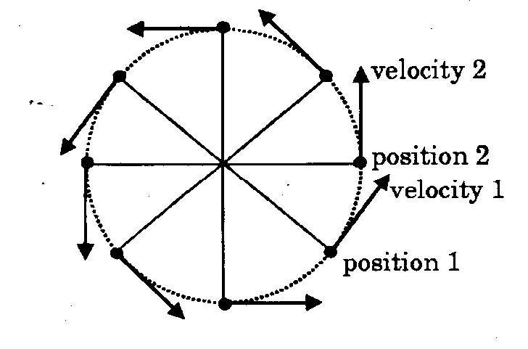**Newton's First Law** says that ‘*any object remains at rest or moving with constant speed in a straight line unless acted on by a* ***force*.’**

Since the stone is neither at rest nor moving in a straight line, a force must be acting on it.

Forces produce acceleration as stated by **Newton's Second Law.** Why is a stone whirled around on the end of a string accelerating?

At each point the stone has an *instantaneous linear, or tangential, velocity* in a particular direction. An instant later, as the position of the stone changes its velocity also changes direction.

Remember, *velocity is a vector quantity* and therefore as soon as the direction changes it becomes a new velocity, even though the speed of the stone has not changed.

Acceleration occurs when velocity changes, therefore any object moving in a circle is accelerating. This acceleration is called ***centripetal acceleration.***

**Centripetal Acceleration**

Centripetal means *centre seeking*, which suggests that the acceleration of an object moving in a circle is directed towards the centre.

$$a= \frac{∆v}{∆t}= \frac{v-v_{0}}{∆t}$$

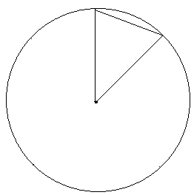

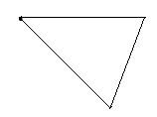

**Centripetal acceleration is always directed towards the centre of the circle.**

**Derivation of the centripetal acceleration formula:**

Notes about the centripetal acceleration formula:

* The formula gives only the magnitude of the acceleration, the direction is at all times along the radius directed towards the centre of the circle
* The centripetal acceleration depends of the tangential speed of the body and the radius of the path it travels. Thus for a given speed and radius the centripetal acceleration is fixed

**Relationship between period and linear velocity**

The period, ***T***, of an object moving in a circle is the time it takes to make one revolution or travel around the circle once.

For one revolution, the distance travelled is the circumference of the circle, which is 2π*r*, and the time is the period, *T*.

Since *v* is given by $\frac{s}{t} →v= \frac{s}{t}= \frac{2πr}{T}$

Alternatively T =

**Example Question**

A student finds that the time for 10 revolutions of a stone, being whirled aroun on a string 0.5m long is exactly 8 seconds.

1. What is the period of the stone?
2. What is the linear speed of the stone?
3. What is the centripetal acceleration?

**Questions**

1. A car travelling at 30 km/h is travelling around a bend of radius 100m
   1. What is the centripetal acceleration?
   2. What will be it centripetal acceleration if:
      1. It travels at the same speed around a bend of radius 70m?
      2. It travels at 60 km/h around a bend of radius 25m?
2. The Moon orbits about the Earth in an approximately circular path with a mean radius of 384 000 km. The Moon completes one revolution in 27.3 days. Find:
   1. The orbital speed of the Moon.
   2. The centripetal acceleration of the Moon.
3. Car A travels around a sharp bend at 60 km/h and car B travels around a gentle curve at the same speed. Which car has the greater centripetal acceleration acting on it?
4. “Uniform circular motion refers to the motion of bodies moving in a circle of fixed radius with constant velocity”. Is this statement correct? If not explain why not.
5. A car, rounding a bend, experiences a centripetal acceleration of 30ms-1. Find its speed in km/h if the radius of the bend is 100m.
6. A motorbike rounding a bend experiences a centripetal acceleration of 20ms-1. Use proportionality relationships to find its centripetal acceleration if:
   1. The speed is doubled
   2. The speed is halved
   3. The radius of the bend is doubled
   4. The speed is doubled and the radius is halved.