STAGE 2 PHYSICS
This enables students to demonstrate evidence of their knowledge and understanding of the Key Ideas and Intended Student Learning in the Topic: Motion in Two Dimensions.

Skills and Applications Task: Motion in two dimensions

Purpose
This assessment provides you with the opportunity to demonstrate your ability:
- to represent, analyse, and interpret data from investigations in physics through the use of technology and numeracy skills
- communicate knowledge and understanding of the concepts and information of physics using the appropriate literacy skills of physics
Communicating clear expectations of the detail and quality of communication required supports students at all levels to provide evidence against the specific features being assessed.
- demonstrate and apply knowledge and understanding of physics to a range of applications and problems relating to Motion in Two Dimensions.

Description of assessment
In this assessment you need to:
- communicate your knowledge and understanding clearly and concisely
- use physics terms correctly
- present information in an organised and logical sequence
- include only information that is relevant to the question
- use clearly labelled diagrams that are related to your answer
- show all steps and reasoning in your answer
- give answers with appropriate units and direction
You may use the formula sheet provided to select appropriate formulae.
Completing the entire task under direct supervision contributes to subject outline requirement of at least three Skills and Applications Tasks under direct supervision.

Assessment conditions
This is a supervised 80 minute closed-book assessment completed under test conditions.
A calculator may be used.

The questions in this Skills and Applications task have been taken, with some minor adaptations, from previous SACE Board Stage 2 Physics examinations. Using these questions allows students to become familiar with the terminology, language, question styles, and the level of difficulty of questions used in SACE Board examinations.

In selecting questions, consideration has been given to the following:
- Questions should allow all students to demonstrate their level of understanding and skills against the performance standards. Hence the wording and demands of the questions vary from routine to more complex.
- Students typically find some concepts in Physics more difficult than others. Setting questions from the full range of Key Ideas enables students to provide evidence at all levels of the performance standards.
- Information about the types of concepts and skills that students typically find challenging has been obtained from the Assessment Report prepared each year by the Chief Assessor.

This task focuses on the assessment of specific features from Application and Knowledge and Understanding as these assessment design criteria are better suited to the nature of skills and applications tasks. Other skills and applications tasks provide evidence for assessment of specific features in Investigation and Analysis and Evaluation.

Learning Requirements | Assessment Design Criteria | Capabilities
1. identify and formulate questions, hypotheses, concepts, and purposes that guide investigations in physics  2. design and conduct collaborative and individual investigations in physics using appropriate apparatus and safe working practices and by observing, recording, and interpreting the phenomena of physics  3. represent, analyse, interpret, and evaluate investigations in physics through the use of technology and numeracy skills  4. select, analyse, and critically evaluate the evidence of physics from different sources, and present informed conclusions or decisions on contemporary physics applications  5. communicate knowledge and understanding of the concepts and information of physics using appropriate physics terms and conventions  6. demonstrate and apply knowledge and understanding of physics to a range of applications and problems. | Investigation  The specific features are as follows:  I1 Design of physics investigations.  I2 Selection and acknowledgment of information and data about physics and issues in physics from different sources.  I3 Manipulation of apparatus and technological tools to implement safe and ethical investigation procedures.  I4 The obtaining, recording, and display of findings of investigations using appropriate conventions and formats.  Analysis and Evaluation  The specific features are as follows:  AE1 Analysis of data and concepts and their connections, to formulate conclusions and make relevant predictions.  AE2 Evaluation of procedures, with suggestions for improvement.  Application  The specific features are as follows:  A1 Application of physics concepts and evidence from investigations to solve problems in new and familiar contexts.  A2 Use of appropriate physics terms, conventions, formulae, and equations.  A3 Demonstration of skills in individual and collaborative work.  Knowledge and Understanding  The specific features are as follows:  KU1 Demonstration of knowledge and understanding of physics concepts.  KU2 Use of knowledge of physics to understand and explain contemporary issues and applications.  KU3 Communication of knowledge and understanding of physics in different formats. | Communication  Citizenship  Personal Development  Work  Learning

Performance Standards for Stage 2 Physics
 | Investigation | Analysis and Evaluation | Application | Knowledge and Understanding
A | Designs logical, coherent, and detailed physics investigations.  Critically and logically selects and consistently and appropriately acknowledges information about physics and issues in physics from a range of sources.  Manipulates apparatus and technological tools carefully and highly effectively to implement well-organised safe and ethical investigation procedures.  Obtains, records, and displays findings of investigations using appropriate conventions and formats accurately and highly effectively. | Critically and systematically analyses data and their connections with concepts to formulate logical and perceptive conclusions and make relevant predictions.  Critically and logically evaluates procedures and suggests a range of appropriate improvements. | Applies physics concepts and evidence from investigations to suggest solutions to complex problems in new and familiar contexts.  Uses appropriate physics terms, conventions, formulae, and equations highly effectively.  Demonstrates initiative in applying constructive and focused individual and collaborative work skills. | Consistently demonstrates a deep and broad knowledge and understanding of a range of physics concepts.  Uses knowledge of physics perceptively and logically to understand and explain contemporary applications.  Uses a variety of formats to communicate knowledge and understanding of physics coherently and highly effectively.
B | Designs well-considered and clear physics investigations.  Logically selects and appropriately acknowledges information about physics and issues in physics from different sources.  Manipulates apparatus and technological tools carefully and mostly effectively to implement organised safe and ethical work investigation procedures.  Obtains, records, and displays findings of investigations using appropriate conventions and formats mostly accurately and effectively. | Clearly and logically analyses data and their connections with concepts to formulate consistent conclusions and make mostly relevant predictions.  Logically evaluates procedures and suggests some appropriate improvements. | Applies physics concepts and evidence from investigations to suggest solutions to problems in new and familiar contexts.  Uses appropriate physics terms, conventions, formulae, and equations effectively.  Applies mostly constructive and focused individual and collaborative work skills. | Demonstrates some depth and breadth of knowledge and understanding of a range of physics concepts.  Uses knowledge of physics logically to understand and explain contemporary applications.  Uses a variety of formats to communicate knowledge and understanding of physics coherently and effectively.
C | Designs considered and generally clear physics investigations.  Selects with some focus, and mostly appropriately acknowledges, information about physics and issues in physics from different sources.  Manipulates apparatus and technological tools generally carefully and effectively to implement safe and ethical investigation procedures.  Obtains, records, and displays findings of investigations using generally appropriate conventions and formats with some errors but generally accurately and effectively. | Analyses data and their connections with concepts to formulate generally appropriate conclusions and make simple predictions with some relevance.  Evaluates some procedures in physics and suggests some improvements that are generally appropriate. | Applies physics concepts and evidence from investigations to suggest some solutions to basic problems in new or familiar contexts.  Uses generally appropriate physics terms, conventions, formulae, and equations with some general effectiveness.  Applies generally constructive individual and collaborative work skills. | Demonstrates knowledge and understanding of a general range of physics concepts.  Uses knowledge of physics with some logic to understand and explain one or more contemporary applications.  Uses different formats to communicate knowledge and understanding of physics with some general effectiveness.
D | Prepares the outline of one or more physics investigations.  Selects and may partly acknowledge one or more sources of information about physics or an issue in physics.  Uses apparatus and technological tools with inconsistent care and effectiveness and attempts to implement safe and ethical investigation procedures.  Obtains, records, and displays findings of investigations using conventions and formats inconsistently, with occasional accuracy and effectiveness. | Describes basic connections between some data and concepts and attempts to formulate a conclusion and make a simple prediction that may be relevant.  For some procedures, identifies improvements that may be made. | Applies some evidence to describe some basic problems and identify one or more simple solutions, in familiar contexts.  Attempts to use some physics terms, conventions, formulae, and equations that may be appropriate.  Attempts individual work inconsistently, and contributes superficially to aspects of collaborative work. | Demonstrates some basic knowledge and partial understanding of physics concepts.  Identifies and explains some physics information that is relevant to one or more contemporary applications.  Communicates basic information to others using one or more formats.
E | Identifies a simple procedure for a physics investigation.  Identifies a source of information about physics or an issue in physics.  Attempts to use apparatus and technological tools with limited effectiveness or attention to safe or ethical investigation procedures.  Attempts to record and display some descriptive information about an investigation, with limited accuracy or effectiveness. | Attempts to connect data with concepts, formulate a conclusion and make a prediction.  Acknowledges the need for improvements in one or more procedures. | Identifies a basic problem and attempts to identify a solution in a familiar context.  Uses some physics terms or formulae.  Shows emerging skills in individual and collaborative work. | Demonstrates some limited recognition and awareness of physics concepts.  Shows an emerging understanding that some physics information is relevant to contemporary applications.  Attempts to communicate information about physics.
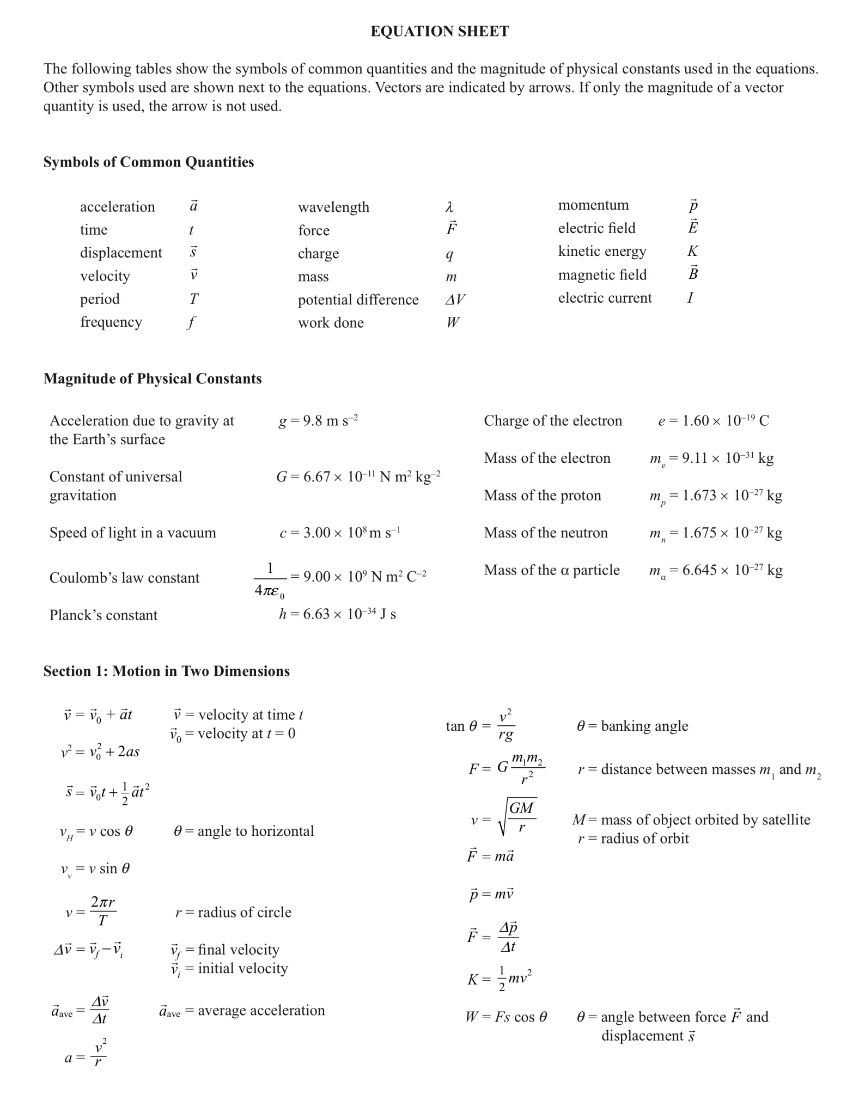
Providing the full Equation Sheet in all Skills and Tasks develops the student’s ability to sort relevant information from irrelevant information in the symbols and equations on the sheet.

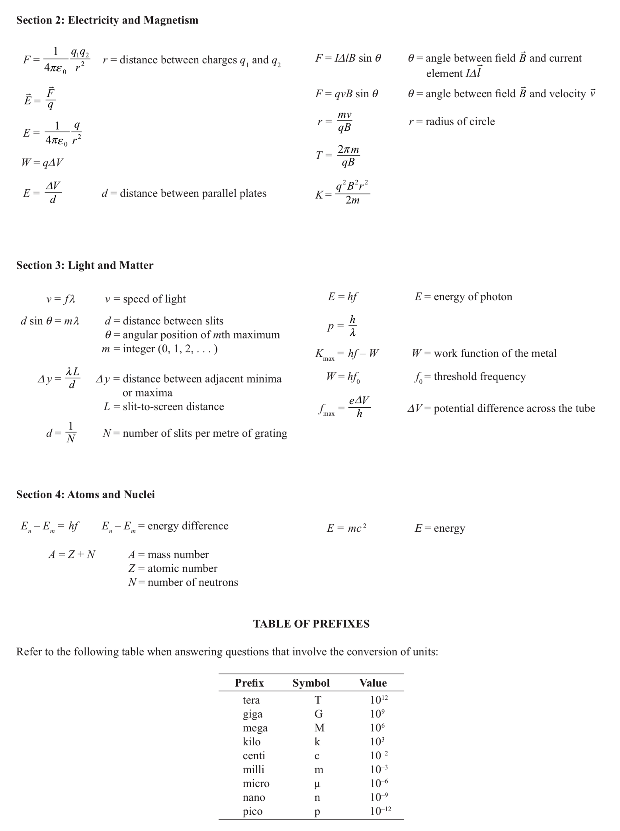
STAGE 2 PHYSICS
Skills and Applications Task: Motion in two dimensions

1. The parabolic path of a small particle projected in the Earth’s constant gravitational field is shown in the diagram below. Draw labelled arrows from A and B to indicate the direction of the velocity and the acceleration at each of these points.
B
V should be in line with the direction of travel
A should be downwards

A

(4 marks)
2. The multi-image diagram below represents the motion of a projectile launched from the ground. The time interval between images is 1.0 s. Assume negligible air resistance for the motion shown.

Using the information shown in the diagram above:
(a) calculate the horizontal speed of the projectile.
40m/4s = 10m/s __________________ (3 marks)
(b) state the maximum height reached by the projectile.
20m _____________________________________________ (1 mark)
(c) calculate the magnitude of the vertical acceleration of the projectile.
s = ½ at²
a = $\frac{2s}{t^{2}}$
a = 2*20/2²
a = 10 ms⁻²
(3 marks)
3. You ar11e in an open-top car, travelling east along a horizontal straight road at a constant speed of 25 m s⁻¹. You throw a ball vertically upwards at a speed of 11 m s⁻¹.
(Ignore air resistance. Gravitational acceleration = 9.8 m s⁻² directed downwards.)
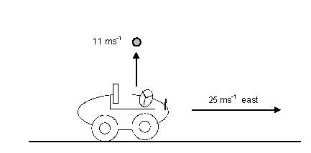
(a) State the magnitude of the horizontal component of the velocity of the ball at the instant the ball leaves your hand.
___25 ms⁻¹______________________ (1 mark)
(b) Show that the time the ball takes to return to the same height from which it was thrown is 2.2 s.
v = v₀ + at
t₁ = $\frac{v – v0}{a}$
t₁ = -11/-9.8
t₁ = 1.12
total t = t₁ x 2
t = 2.2s ____ (2 marks)
(c) Calculate the speed of the ball 2.0 s after it leaves your hand.
25
v_{v} = v₀ + at
v_{v} = 11 – 9.8 x 2
v
v_{v} = -8.6 ms⁻¹

v_{H} = 25 ms⁻¹

v = $\sqrt{v_{v}^{2}+v_{H}^{2}}$
v = $\sqrt{{8.6}^{2}+{25}^{2}}$
v = 26 ms⁻¹
8.6

(4 marks)

(d) Describe and explain where a ball would land in relation to the car if the ball encountered significant air resistance. Assume the effect of air resistance on the car is negligible.
This question refers to a contemporary application in the content section for this topic in the Subject Outline.
The air resistance would affect both the horizontal and vertical components of the balls velocity. By reducing the horizontal component of the velocity, it would cause the ball to fall behind the car due to now having a lower horizontal velocity than the car. (2 marks)
4. A puck of mass m =0.30 kg is moving with uniform circular motion on a horizontal air table. The length of the string attached to the puck is r = 0.10 m, as shown in the diagram below. The period of the puck’s circular motion about point X is 6.28 s.

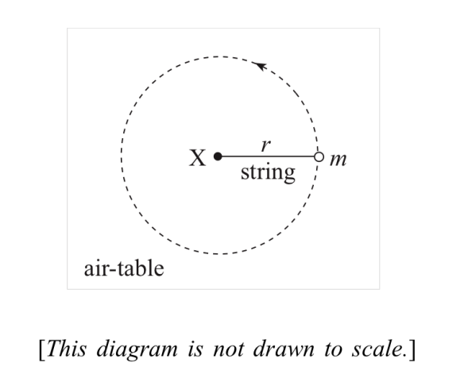
- Identify the force that is causing the centripetal acceleration of the puck.
The centripetal force is caused by the tension in the string_________ (1 mark)

- Show that the magnitude of the tension F in the string is given by F =
$$F=\frac{mv^{2}}{r} and v= \frac{2πr}{T}$$
$$∴F= \frac{m}{r}×{\left(\frac{2πr}{T}\right)}^{2}$$
$$∴F= \frac{4π^{2}mr^{2}}{T^{2}r}$$
$$∴F= \frac{4π^{2}mr}{T^{2}}$$
( 3 marks)
- Hence calculate the magnitude of the tension in the string.
F = 4 x π² x 0.3 x 0.1 / 6.28²
F = 0.030 N (2 marks)
5. In an experiment a small ball is attached to a cord of negligible mass that passes through a glass tube, as shown in the diagram below. Also attached to the cord is a mass M, which hangs vertically below the glass tube.
The ball is moving in a horizontal circle at a constant radius with a tangential speed of v m s⁻¹. During the experiment the mass M is varied and the corresponding value of the tangential speed v of the ball is measured.

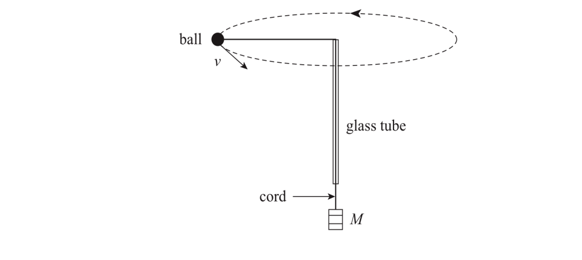
The graph below shows the square of the tangential speed v² versus the mass M:

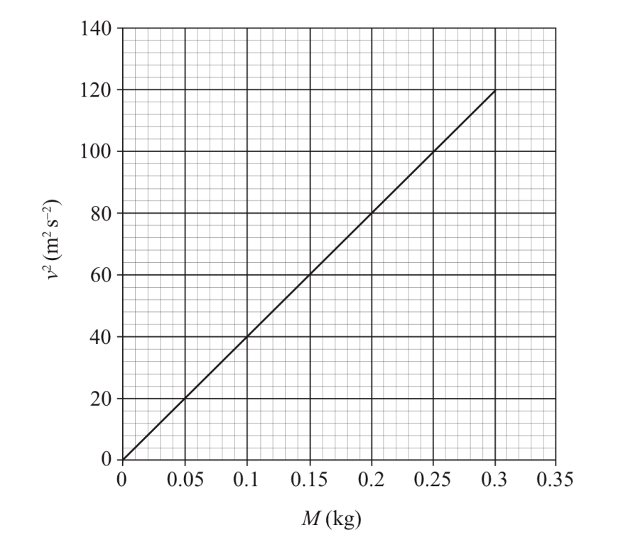
Analysis and Evaluation
Provides students with the opportunity to analyse information to formulate conclusions.
Calculate the gradient of the line of best fit shown on the graph above. Include the unit of the gradient. Clearly label on the graph the points you have used in your calculation.
Slope = $\frac{∆y}{∆x}$
Slope = 120 / 0.3
Slope = 400 m²s⁻²kg⁻¹

( 3 marks)
6. A car travels round a circular curve on a flat, horizontal road at a radius of 42m, as shown in the diagram below:

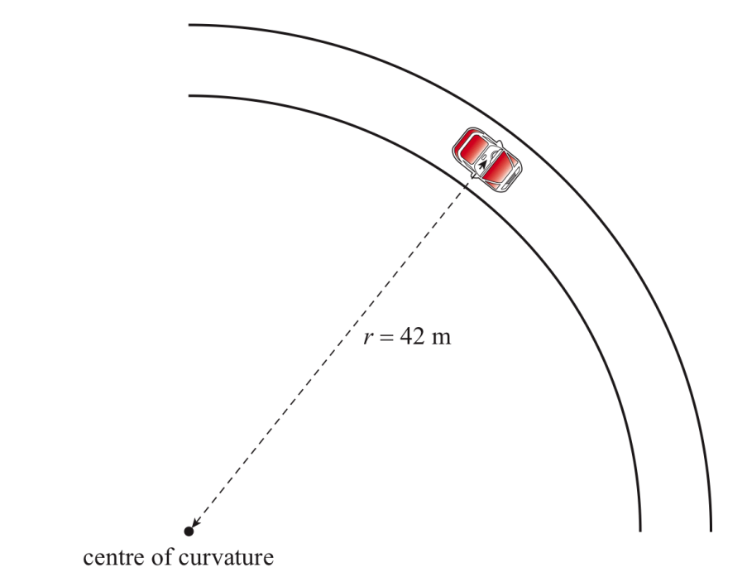

(a) Draw an arrow on the diagram above to show the direction of the frictional force needed for the car to travel round the curve at a radius of 42m. (1 mark)

(b) The maximum frictional force between the tyres and the road is equal to 20% of the weight of the car.
Calculate the maximum speed at which the car can travel round the curve at a constant radius of 42 m.
F = 0.2mg and F = $\frac{mv^{2}}{r}$
0.2mg = mv²/r
v² = 0.2rg
v = $\sqrt{0.2rg}$
v = $\sqrt{0.2 ×42×9.8}$
v = 9.1 ms⁻¹ (4 marks)

7. The exit of a freeway has been designed so that a car can travel safely around the curved section of the ramp when the road is wet. The banking angle θ enables a car to travel around the curved section of the ramp without relying on friction, as shown in the diagram below:
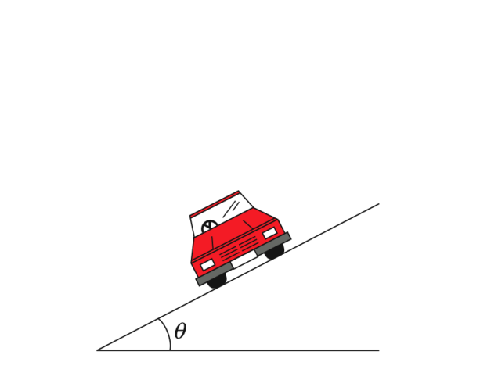
- On the diagram above, draw and label a vector to show the normal force acting on the car. (1 mark)
- Using the vector you have drawn in part (a), explain how the banking angle enables the car to travel around the curved section of the ramp without relying on the friction.
Knowledge and Understanding Contemporary application of physics.
The normal force can be broken down into horizontal and vertical components. The horizontal component of the normal force is towards the centre of the curve, and thereby provides some centripetal force without relying on the frictional force from the tyres (3 marks)

- The curved section of the ramp has a radius of 150 m and the banking angle is 11°.
Calculate the maximum speed at which the car can travel around the curve without relying on friction.
$$\tan{θ= \frac{v^{2}}{rg}}$$
$$v= \sqrt{rg\tan{θ}}$$
$$v= \sqrt{150×9.8×\tan{11}}$$
v = 16.9 ms⁻¹
__ (2 marks)

8. The polar-orbiting satellite NOAA-N was launched in May 2005, as shown in the photograph below:
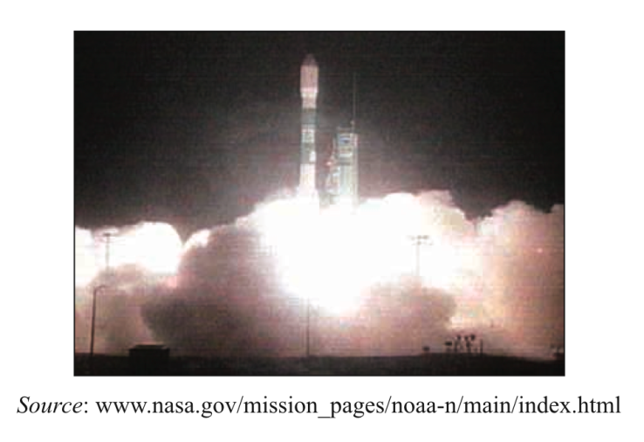
The satellite is now moving in a circular orbit above the Earth’s surface at an altitude of 870 km. The mass of the Earth is 5.97 x 10²⁴ kg and its mean radius is 6.38 x 10⁶ m.
- Show that the orbital speed of the satellite is 7.41 x 10³ ms⁻¹.
$$v=\sqrt{\frac{GM}{r}}$$
$$v=\sqrt{\frac{6.67×{10}^{-11}×5.97×{10}^{24}}{6.38×{10}^{6}+8.7×{10}^{5}}}$$
$v=7411$ms⁻¹
(2 marks)
- Calculate the magnitude of the acceleration due to gravity at the satellite’s altitude.
$$ma= \frac{GmM}{r^{2}}$$
$$a= \frac{GM}{r^{2}}$$
$$a= \frac{6.67×{10}^{-11}×5.97×{10}^{24}}{(6.38×{10}^{6}+8.7×{10}^{5})^{2}}$$
a = 7.58 ms⁻²

(3 marks)
9. A satellite orbits the Earth in a circular path, as shown in the diagram below:
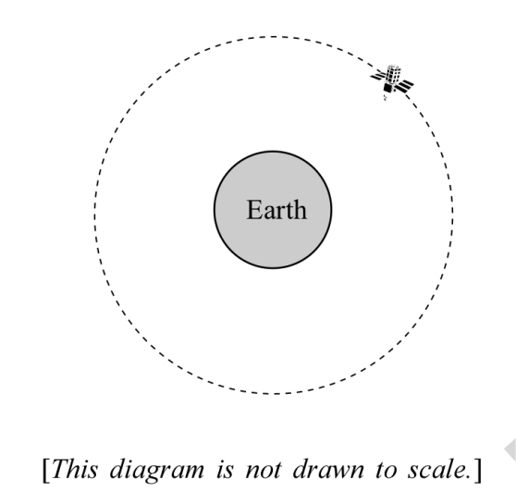
- On the diagram above, draw a vector to represent the acceleration of the satellite. (1 mark)
- The satellite orbits the Earth at a radius of 4.224 x 10⁷ m and a speed of 3072 m s⁻¹. Calculate the orbital period of the satellite to the appropriate number of significant figures.
Application
Questions assessing the application of physics concepts range from routine and familiar to more complex to allow students at all levels to provide evidence of their ability.
$$T= \frac{2πr}{v}$$
$$T= \frac{2π×4.224×{10}^{7}}{3072}$$
T = 8.639 x 10⁴

(3 marks)
- (i) Show that the period squared T² of the satellites orbiting the Earth is directly proportional to their radius cubed (T² α r³ ). Use the equations
v = and v = .
$$\sqrt{\frac{GM}{r}}=\frac{2πr}{T}$$
$$\frac{GM}{r}=\frac{4π^{2}r^{2}}{T^{2}}$$
GMT² = 4π²r³
G, M, 4 and π are constants. Therefore T² ∝ r³

(3 marks)
(ii) Hence explain why geostationary satellites have orbits of relatively large radius in comparison with other artificial satellites that move with uniform circular motion about the Earth.
as T² ∝ r³, satellites with a relatively large period need a correspondingly large radius. Geostationary satellites must have a period of approximately 24h to correspond with the Earth’s rotation. Other satellites can have a much shorter period of about 2h. Therefore the radius needs to be much larger for a geostationary satellite
Knowledge and Understanding Contemporary application of physics.
(3 marks)
10. A basketball moving at a speed of 5.0 m s⁻¹ collides with a wall. The basketball is in contact with the wall for 0.050 s and bounces off the wall without a change of speed. The basketball is moving at 30.0º to the normal immediately before and after the collision, as shown in the diagram below:
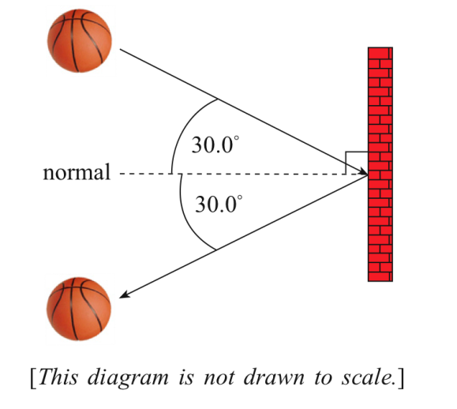
120
Δv
30
30
5ms⁻¹
5ms⁻¹
(a) (i) Draw a labelled vector diagram to determine the change in velocity of the basketball as a result of the collision with the wall. Use the initial and final velocity vectors in your diagram. (3 marks)
(ii) Hence show that the magnitude of the change in velocity of the basketball as a result of the collision is 8.7 m s⁻¹.
$$∆v= \sqrt{5^{2}+5^{2}-2×5×5×\cos{120}}$$
Δv = 8.7 ms⁻¹

Note that the cosine and sine rules are assumed knowledge and are unfortunately not included on the formula sheet.
(3 marks)

11. Two vehicles collide and lock together.
The collision occurs at an intersection where vehicle A (1100 kg) is travelling due east and vehicle B (1300 kg) is travelling due north.
After the collision the wrecked motor vehicles remain locked together and move in the direction shown in the diagram below.
Assume that the collision is an isolated one.

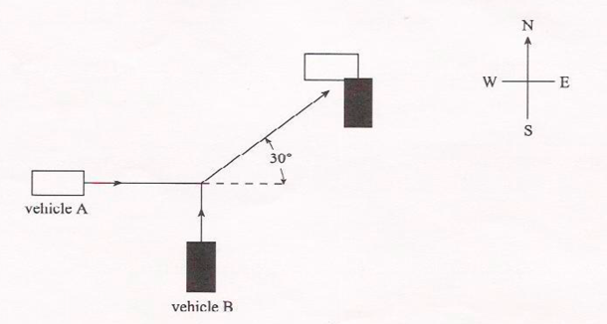

Vehicle A was travelling at 32 m s⁻¹ before the collision and the speed of the vehicles after collision was 17 m s⁻¹.
Calculate the speed of vehicle B before the collision.

p_{f} = 17 x 2400 p_{total}
p_{f} = 40 800 Ns p_{B}
p_{i} = p_{f}
p_{A}
p_{i} = 40 800
p_{A} = 32 x 1100
p_{A} = 35 200

p_{B} = $\sqrt{{40800}^{2}-{35200}^{2}}$
p_{B} = 20 630 Ns
v = p/m
v = 20 630 / 1300
v = 15.9 ms⁻¹ (6 marks)
12. Two identical objects of equal mass m, moving with the same initial speed ½ v, collide. After the collision the two objects join together and move off as one object of mass 2m, with speed ¼ v, as shown in the diagram below. The angle θ between the directions of the initial velocities is also shown in the diagram.
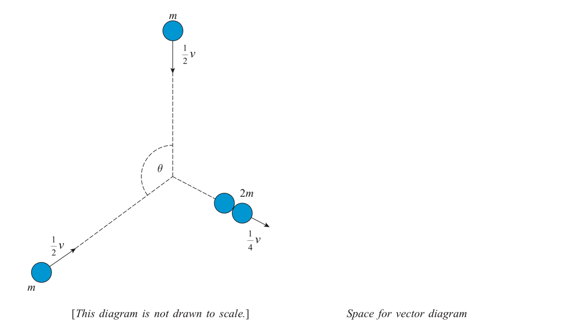
Determine the value of θ, drawing a labelled vector diagram in the space above. Assume an isolated system.
p₁ = 0.5mv p₂ = 0.5mv p_{f} = 0.25x2mv = 0.5mv
all three momenta are equal
therefore triangle is equilateral
therefore internal angle is 60°
therefore θ is 120° (2x60)

(5 marks)

13. A collision between two pucks on an air table is represented in the multi-image diagram below. The mass of puck A is 2m and the mass of puck B is m. After the collision the two pucks stick together and move off as a single object.
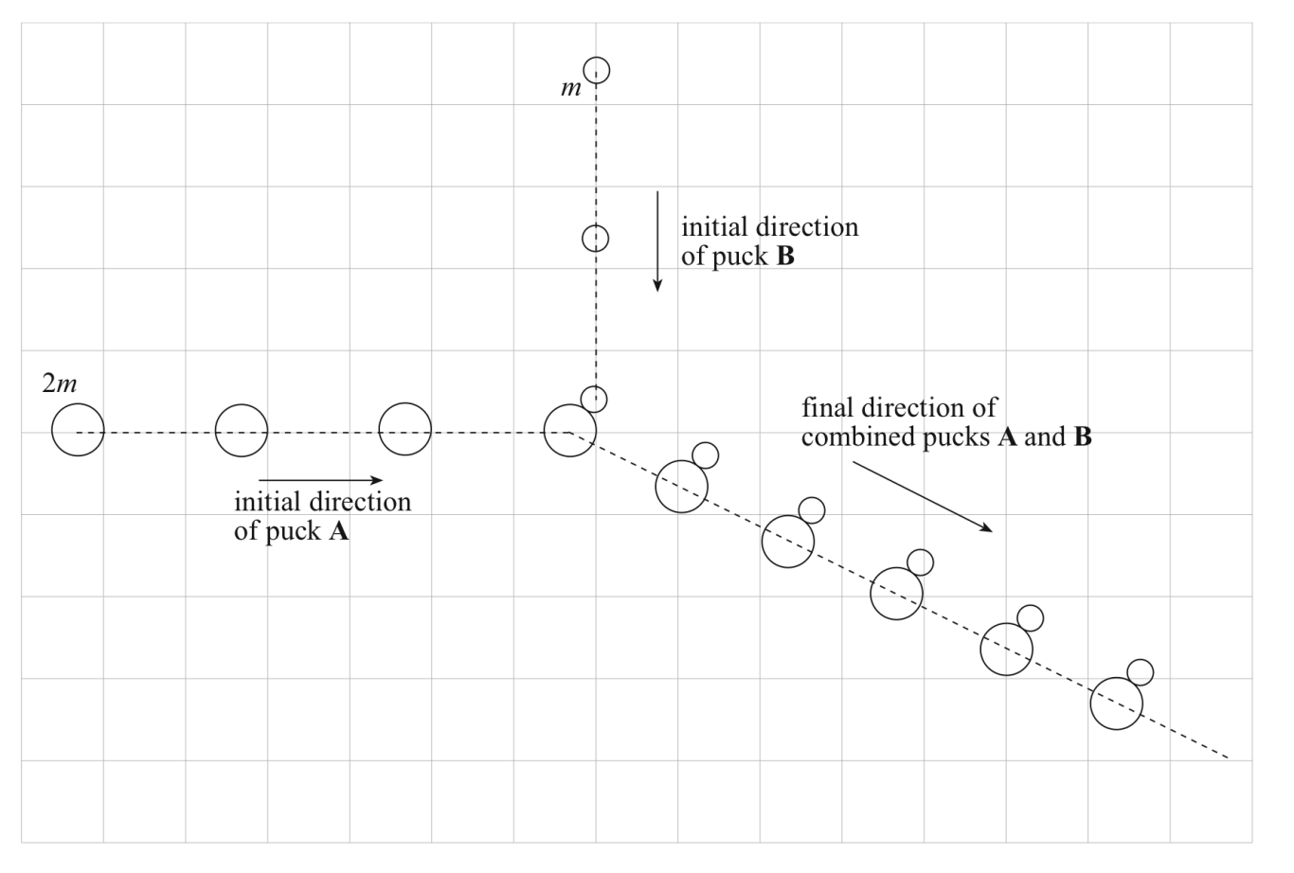
Analysis and Evaluation
Provides students with the opportunity to analyse and data and other evidence to formulate conclusions and make relevant predictions.
(a) Describe evidence from the diagram indicating that no external forces are acting on the combined pucks after the collision.
Velocities are constant before and after the collision, therefore no acceleration during these times and therefore no force acting. (2 marks)
(b) On the diagram above, draw and label vectors representing the momentum of puck A before the collision, the momentum of puck B before the collision, and the momentum of the combined pucks A and B after the collision. (3 marks)
(c) With the aid of a vector diagram drawn on the diagram above, explain whether momentum was conserved in this collision.
vector diagram shown above indicates that vectorally p_{A} + p_{B} = p_{AB}
Additional comments
Throughout the task, students provide evidence of their ability to:
- use appropriate physics terms, conventions, formulae, and equations.
- demonstrate knowledge and understanding of physics concepts.
This shows that the total momentum before and after the collision is the same and therefore momentum was conserved during this collision. (3 marks)

