Stage 2 Physics

Skills Assessment Task: Atoms and Nuclei

Name: __________________________
Purpose
This assessment provides you with the opportunity to demonstrate your ability to represent, analyse, and interpret investigations in physics through the use of technology and numeracy skills, communicate knowledge and understanding of the concepts and information of physics using the appropriate literacy skills of physics and demonstrate and apply knowledge and understanding of physics to a range of applications and problems relating to atoms and nuclei.

Description of assessment
In this assessment you need to:
- communicate your knowledge and understanding clearly and concisely
- use physics terms correctly
- present information in an organised and logical sequence
- include only information that is relevant to the question
- use clearly labelled diagrams that are related to your answer
- show all steps and reasoning in your answer
- give answers with appropriate units and direction.
You may use the formula sheet provided to select appropriate formulae.

Assessment conditions
This is a supervised 80 minute closed-book assessment completed under test conditions in one lesson. Total 80 marks. A calculator may be used.

Performance Standards for Stage 2 Physics
 | Investigation | Analysis and Evaluation | Application | Knowledge and Understanding
A | Designs logical, coherent, and detailed physics investigations.  Critically and logically selects and consistently and appropriately acknowledges information about physics and issues in physics from a range of sources.  Manipulates apparatus and technological tools carefully and highly effectively to implement well-organised safe and ethical investigation procedures.  Obtains, records, and displays findings of investigations using appropriate conventions and formats accurately and highly effectively. | Critically and logically analyses and evaluates connections between data, concepts, and issues in physics.  Critically and logically evaluates procedures and suggests a range of appropriate improvements.  Systematically and perceptively analyses and evaluates data and other evidence to formulate conclusions and make logical and highly relevant predictions. | Applies physics concepts and evidence from investigations to suggest solutions to complex problems in new and familiar contexts.  Uses appropriate physics terms, conventions, formulae, and equations highly effectively.  Demonstrates initiative in applying constructive and focused individual and collaborative work skills. | Consistently demonstrates a deep and broad knowledge and understanding of a range of physics concepts.  Uses knowledge of physics perceptively and logically to understand and explain contemporary applications.  Uses a variety of formats to communicate knowledge and understanding of physics coherently and highly effectively.
B | Designs well-considered and clear physics investigations.  Logically selects and appropriately acknowledges information about physics and issues in physics from different sources.  Manipulates apparatus and technological tools carefully and mostly effectively to implement organised safe and ethical work investigation procedures.  Obtains, records, and displays findings of investigations using appropriate conventions and formats mostly accurately and effectively. | Clearly and logically analyses and evaluates connections between data, concepts, and issues in physics.  Logically evaluates procedures and suggests some appropriate improvements.  Uses mostly logical analysis and evaluation of data and other evidence to formulate conclusions and make consistent and relevant predictions. | Applies physics concepts and evidence from investigations to suggest solutions to problems in new and familiar contexts.  Uses appropriate physics terms, conventions, formulae, and equations effectively.  Applies mostly constructive and focused individual and collaborative work skills. | Demonstrates some depth and breadth of knowledge and understanding of a range of physics concepts.  Uses knowledge of physics logically to understand and explain contemporary applications.  Uses a variety of formats to communicate knowledge and understanding of physics coherently and effectively.
C | Designs considered and generally clear physics investigations.  Selects with some focus, and mostly appropriately acknowledges, information about physics and issues in physics from different sources.  Manipulates apparatus and technological tools generally carefully and effectively to implement safe and ethical investigation procedures.  Obtains, records, and displays findings of investigations using generally appropriate conventions and formats with some errors but generally accurately and effectively. | Analyses and evaluates connections between data, concepts, and issues in physics.  Evaluates some procedures in physics and suggests some improvements that are generally appropriate.  Analyses and evaluates data and other evidence to formulate conclusions and make simple and generally relevant predictions. | Applies physics concepts and evidence from investigations to suggest some solutions to basic problems in new or familiar contexts.  Uses generally appropriate physics terms, conventions, formulae, and equations with some general effectiveness.  Applies generally constructive individual and collaborative work skills. | Demonstrates knowledge and understanding of a general range of physics concepts.  Uses knowledge of physics with some logic to understand and explain one or more contemporary applications.  Uses different formats to communicate knowledge and understanding of physics with some general effectiveness.
D | Prepares the outline of one or more physics investigations.  Selects and may partly acknowledge one or more sources of information about physics or an issue in physics.  Uses apparatus and technological tools with inconsistent care and effectiveness and attempts to implement safe and ethical investigation procedures.  Obtains, records, and displays findings of investigations using conventions and formats inconsistently, with occasional accuracy and effectiveness. | Describes basic connections between some data, concepts, and issues in physics.  For some procedures, identifies improvements that may be made.  Attempts to extract meaning from data and other observations and to formulate a conclusion or make a simple prediction that may be relevant. | Applies some evidence to describe some basic problems and identify one or more simple solutions, in familiar contexts.  Attempts to use some physics terms, conventions, formulae, and equations that may be appropriate.  Attempts individual work inconsistently, and contributes superficially to aspects of collaborative work. | Demonstrates some basic knowledge and partial understanding of physics concepts.  Identifies and explains some physics information that is relevant to one or more contemporary applications.  Communicates basic information to others using one or more formats.
E | Identifies a simple procedure for a physics investigation.  Identifies a source of information about physics or an issue in physics.  Attempts to use apparatus and technological tools with limited effectiveness or attention to safe or ethical investigation procedures.  Attempts to record and display some descriptive information about an investigation, with limited accuracy or effectiveness. | Acknowledges that connections exist between data, concepts, and/or issues in physics.  Acknowledges the need for improvements in one or more procedures.  Attempts to organise some limited data or observations. | Identifies a basic problem and attempts to identify a solution in a familiar context.  Uses some physics terms or formulae.  Shows emerging skills in individual and collaborative work. | Demonstrates some limited recognition and awareness of physics concepts.  Shows an emerging understanding that some physics information is relevant to contemporary applications.  Attempts to communicate information about physics.

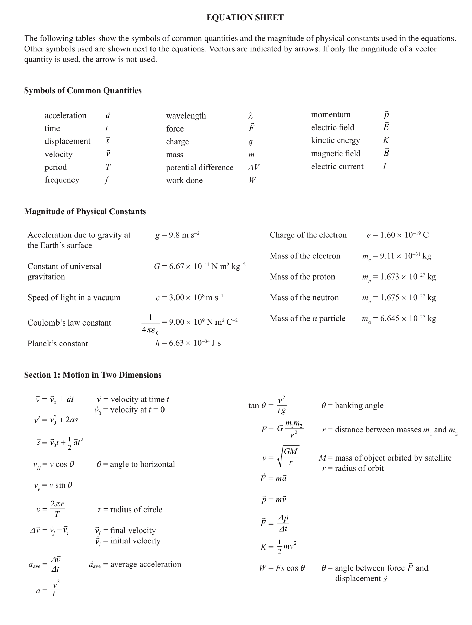

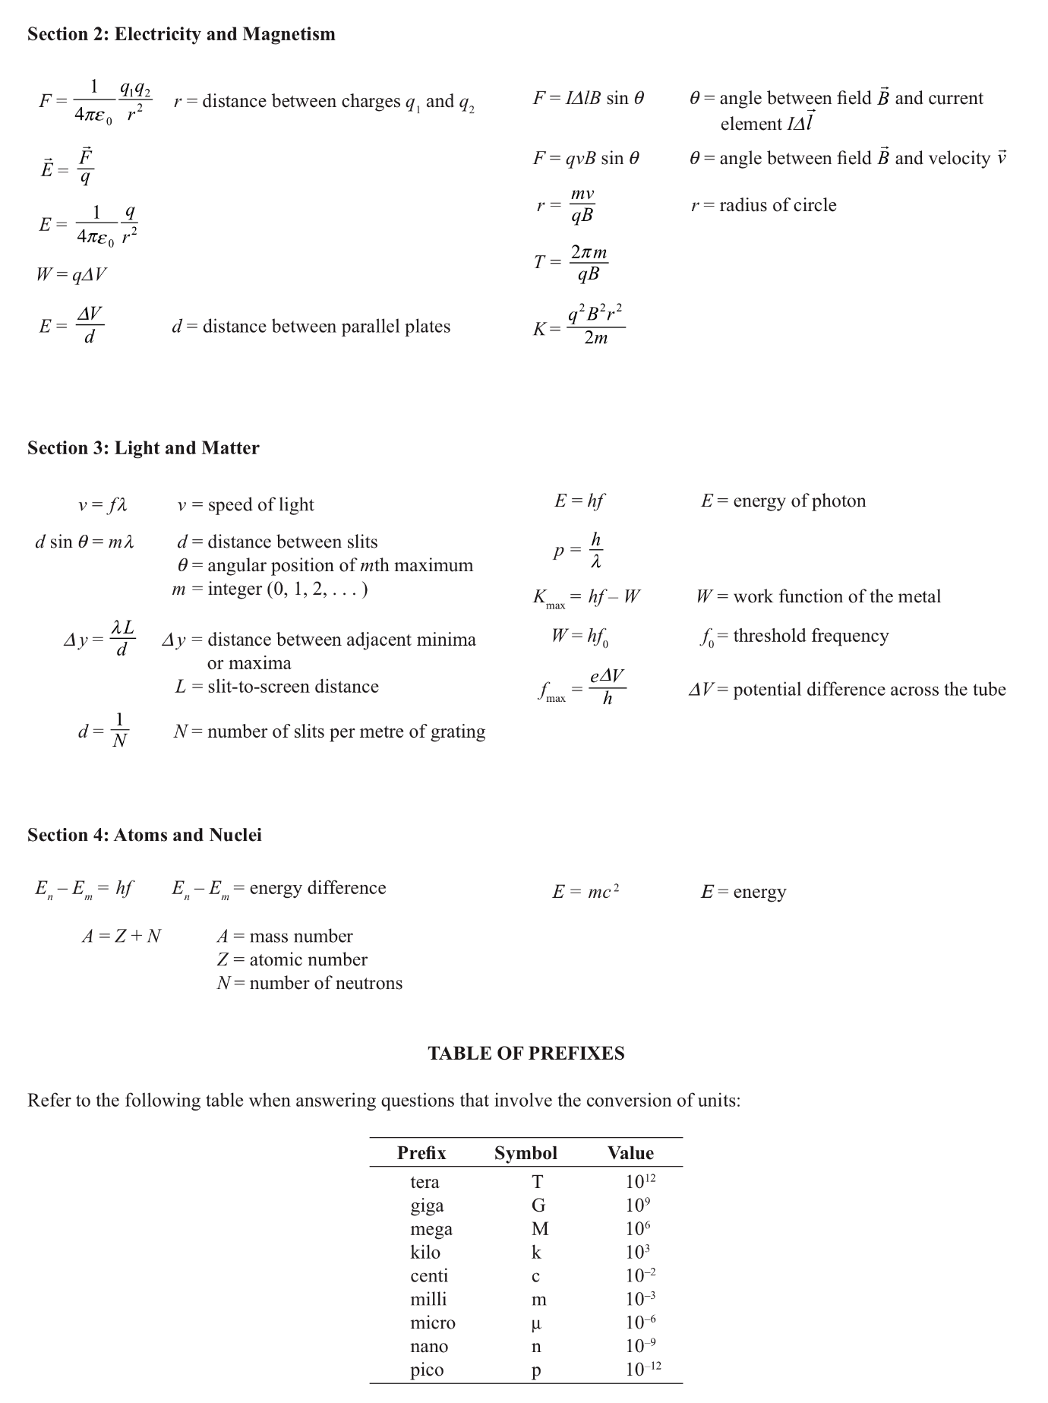

Stage 2 Physics

Skills Assessment Task: Atoms and Nuclei
Name: __________________________
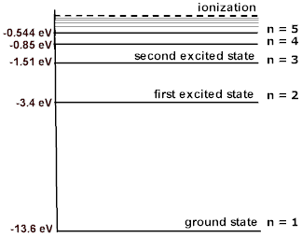
- Shown is an energy-level diagram of hydrogen:

  - An electron makes a transition from the second excited state to the ground state.
    - Show that the frequency of the emitted photon is $2.92×{10}^{15}$Hz. (A, 3 marks)

    - Calculate the wavelength of the emitted photon. (A, 2 marks)

  - On the energy level diagram above:
    - Draw and label with an S the transition that corresponds to the series limit for the emission series ending in the n=2 state. (KU, 1 mark)
    - State the region of the electromagnetic spectrum in which this series limit occurs.
(KU, 1 mark)

  - Determine the ionisation energy required to remove a single electron from the ground state of hydrogen. Give your answer in electron volts. (A, 1 mark)

  - At room temperature, there are no absorption lines in the visible region for hydrogen. Explain this observation. (KU, 2 marks)

- The following spectra are a spectrum of a gaseous nebula and spectra from 4 laboratory emission tubes:
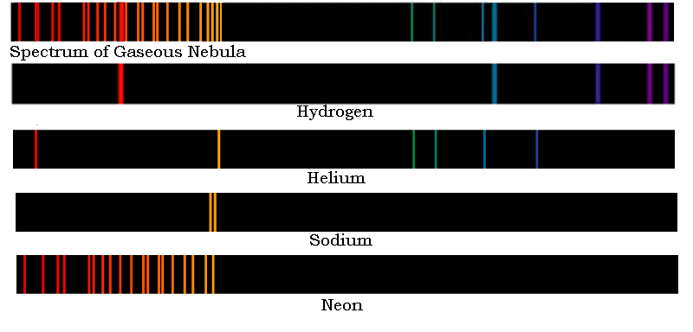
Explain how we can identify the elements present in the gaseous nebula. (A, 3 marks)

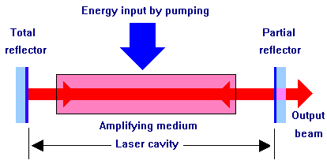
- A laser is different from other sources of light because it emits coherent light. The following diagram is of a laser cavity:
  - Explain why stimulated emission, and not spontaneous emission, is the key to producing coherent light. (KU, 3 marks)

  - State two uses of lasers. (KU, 2 marks)

  - Describe the laser cavity and its purpose. (KU, 4 marks)

- For ${}_{92}^{232}U$, with a nuclear mass of $3.853×{10}^{-25}kg$:
  - State the number of protons in uranium-232. (A, 1 mark)

  - State number of neutrons in uranium-232. (A, 1 mark)

  - Calculate the binding energy of the nucleus. Give your answer in MeV. (A, 4 marks)

  - Explain why isotopes of uranium are chemically identical. (KU, 2 marks)

Uranium-232, ${}_{92}^{232}U,$ decays by alpha decay to thorium-228, ${}_{90}^{228}{Th}$.
  - Write an equation for the above decay process. (A, 1 mark)

  - Explain why the emitted alpha particles have discrete energies. (KU, 3 marks)

  - Using the law of conservation of momentum, show that the ratio of the speed of the alpha nuclei to the speed of the thorium nuclei is approximately 57. Assume that the uranium nuclei is at rest.
(A, 4 marks)

Thorium-228, ${}_{90}^{228}{Th},$ then further decays by emitting a gamma ray.
  - Write an equation for the above decay process. (A, 1 mark)

  - Explain why alpha decay is often accompanied by the emission of discrete gamma rays.
(KU, 3 marks)

- Given a magnetic field out of the page, sketch the deflections of alpha, beta plus, beta minus and gamma particles emitted by the radioactive source.
(KU, 4 marks)
Radioactive source
$$\vec{B}$$

- Strontium-90 has a half-life of 28.8 years. A sample originally contains 12g of strontium-90.
  - How many grams of strontium-90 remains after 57.6 years? (A, 2 marks)

  - How long would it take for the mass of the sample to decrease to 0.75 g? (A, 2 marks)

  - State how the half-life would be affected if the radioactive source was in the form of strontium hydroxide, instead of its metallic form. (KU, 1 marks)

  - Sketch a graph of the grams of radioactive nuclei versus time. (KU, 5 marks)

- Uranium-235 undergoes spontaneous and induced nuclear fission.
  - When a slow neutron is captured by a uranium-235 nucleus, the shape of the nucleus becomes distorted and is forced apart into two roughly equal parts. Explain what is happening inside the nucleus in terms of the interacting forces. (KU, 2 marks)

  - The following is one fission reaction pathway of uranium. Complete the following equation:
$${}_{0}^{1}n+{}_{92}^{235}U→{}_{54}^{A}{Xe}+{}_{Z}^{94}{Sr}+2{}_{0}^{1}n+γ$$
A= ____________________, Z=________________________. (A, 2 marks)

  - Another reaction pathway is:
$${}_{0}^{1}n+{}_{92}^{235}U→{}_{56}^{141}{Ba}+{}_{36}^{92}{Kr}+3{}_{0}^{1}n+γ$$

Calculate the amount of energy released in the above fission reaction. Give your answer in MeV. The nuclear masses are: ${}_{0}^{1}n:1.675×{10}^{-27}kg; {}_{92}^{235}{U:3.9017×{10}^{-25};}{}_{56}^{141}{Ba:2.28922×{10}^{-25}kg;}$
${}_{36}^{92}{Kr=1.57534×{10}^{-25}kg}$. (A, 4 marks)

  - Describe the function of the moderator in a nuclear reactor. (KU, 2 marks)

  - Explain why the most effective moderators have atoms of low mass and low absorption of neutrons. (KU, 2 marks)

  - Nuclei produced by fission reactions are likely to have an excess of neutrons. State the type of radioactive decay they are likely to undergo. (A, 1 mark)

- Positron emission tomography uses beta plus decay to produce photons for imaging.
  - Calculate the energy of each of the photons produced in positron-electron annihilation, assuming that two gamma rays are created and the initial momentum is zero. (A, 3 marks)

  - State one use of the radioisotope fluorine-18 in PET. (KU, 1 mark)

- Discuss one of the following:
  - Advantages and disadvantages of nuclear fission over fossil fuel power stations.
OR
  - Advantages and disadvantages of nuclear fusion over nuclear fission as a future power source.
(KU, 7 marks)

