Circular Motion Practical

Purpose
This assessment task enables you to conduct a practical investigation, identify variables, collect, analyse, and interpret data, evaluate results, draw a conclusion, and communicate your knowledge and understanding of concepts.

Description of Assessment
The folio task is to write a report that includes an investigation of the relationship between the radius of a circle and the period of a revolving mass using the procedure provided. To record the results, present them in a suitable format for analysis, discuss the limitations of the experiment and draw conclusions.
Aim
The aim is to investigate the relationship between the radius of orbit and the period of a particle moving with uniform circular motion.

- Formulate a hypothesis.

Materials/Equipment

a thin pipe or ballpoint pen casing
A bath plug, or some similar rubber or soft synthetic mass
Paper clip
Measuring tape or ruler
1.5 metres of fishing line
A mass of approximately 100 grams
Plastic shopping bag
Stopwatch

- State the Independent Variable and the Dependent Variable in this practical investigation.
- Identify at least three other variables in this practical investigation and explain how they are kept constant.

Procedure
- After reading the rest of the Procedure, describe and explain the safety considerations for this investigation.

- Tie one end of the fishing line to the plug and pass the line through the tube. Attach the other end to the plastic shopping bag with the mass in it.

- Measure a distance of 30 cm from the centre of the plug to the top of the pen casing to determine the radius of the revolving plug.

- Attach the paper clip to the fishing line at a point at the other end of the pen casing.

- Allow the mass to hang free and spin the plug at a rate to maintain the paper clip in a position just below the tube.

- Keep the rate of revolution constant and measure and record the time for 10 revolutions of the plug.

- Repeat this procedure for radius lengths in increments of 10 cm up to 80cm. Conduct 3 trials for each radius length and calculate the average time.

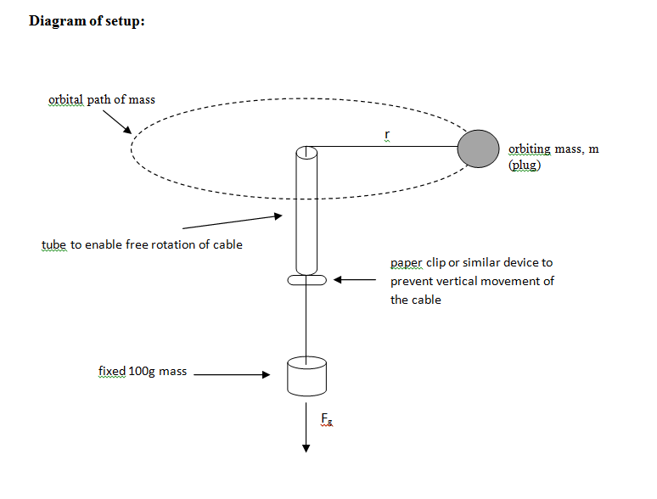
Results

- Record all of your results using an appropriate format.
- Show sample calculations where appropriate

Analysis
- Plot a graph by hand of the period squared, T² against the radius r.
- Calculate the slope of the line of best fit from your graph. Give the units of the slope
- Using the formulae $a=\frac{v^{2}}{r}$ and $v=\frac{2πr}{T}$, show that $T^{2}=\left(\frac{4π^{2}}{a}\right)r$
- Using the analysis of your results and the equation for the line of best fit, find the centripetal acceleration for the object.

Evaluation and Conclusion
- Identify sources of Random Error in your practical investigation and describe how your procedure reduced the effect of these random errors.
- Compare the tension in the string with the calculated force on the stopper (calculated using its speed).
- Identify evidence of Systematic Error in your practical investigation.
Suggest the causes of systematic error. Suggest how you could
identify and/or compensate for the effect of these systematic errors.
- Suggest how the practical investigation could be modified to reduce both the Random and the Systematic errors.
- Write a valid conclusion for your practical investigation.

Performance Standards for Circular Motion Folio
 | Investigation | Analysis and Evaluation | Application | Knowledge and Understanding
A | Designs logical, coherent, and detailed physics investigations.  Critically and logically selects and consistently and appropriately acknowledges information about physics and issues in physics from a range of sources.  Manipulates apparatus and technological tools carefully and highly effectively to implement well-organised safe and ethical investigation procedures.  Obtains, records, and displays findings of investigations using appropriate conventions and formats accurately and highly effectively. | Critically and systematically analyses data and their connections with concepts to formulate logical and perceptive conclusions and make relevant predictions.  Critically and logically evaluates procedures and suggests a range of appropriate improvements. | Applies physics concepts and evidence from investigations to suggest solutions to complex problems in new and familiar contexts.  Uses appropriate physics terms, conventions, formulae, and equations highly effectively.  Demonstrates initiative in applying constructive and focused individual and collaborative work skills. | Consistently demonstrates a deep and broad knowledge and understanding of a range of physics concepts.  Uses knowledge of physics perceptively and logically to understand and explain contemporary issues and applications.  Uses a variety of formats to communicate knowledge and understanding of physics coherently and highly effectively.
B | Designs well-considered and clear physics investigations.  Logically selects and appropriately acknowledges information about physics and issues in physics from different sources.  Manipulates apparatus and technological tools carefully and mostly effectively to implement organised safe and ethical work investigation procedures.  Obtains, records, and displays findings of investigations using appropriate conventions and formats mostly accurately and effectively. | Clearly and logically analyses data and their connections with concepts to formulate consistent conclusions and make mostly relevant predictions.  Logically evaluates procedures and suggests some appropriate improvements. | Applies physics concepts and evidence from investigations to suggest solutions to problems in new and familiar contexts.  Uses appropriate physics terms, conventions, formulae, and equations effectively.  Applies mostly constructive and focused individual and collaborative work skills. | Demonstrates some depth and breadth of knowledge and understanding of a range of physics concepts.  Uses knowledge of physics logically to understand and explain contemporary issues and applications.  Uses a variety of formats to communicate knowledge and understanding of physics coherently and effectively.
C | Designs considered and generally clear physics investigations.  Selects with some focus, and mostly appropriately acknowledges, information about physics and issues in physics from different sources.  Manipulates apparatus and technological tools generally carefully and effectively to implement safe and ethical investigation procedures.  Obtains, records, and displays findings of investigations using generally appropriate conventions and formats with some errors but generally accurately and effectively. | Analyses data and their connections with concepts to formulate generally appropriate conclusions and make simple predictions with some relevance.  Evaluates some procedures in physics and suggests some improvements that are generally appropriate. | Applies physics concepts and evidence from investigations to suggest some solutions to basic problems in new or familiar contexts.  Uses generally appropriate physics terms, conventions, formulae, and equations with some general effectiveness.  Applies generally constructive individual and collaborative work skills. | Demonstrates knowledge and understanding of a general range of physics concepts.  Uses knowledge of physics with some logic to understand and explain one or more contemporary issues and applications.  Uses different formats to communicate knowledge and understanding of physics with some general effectiveness.
D | Prepares the outline of one or more physics investigations.  Selects and may partly acknowledge one or more sources of information about physics or an issue in physics.  Uses apparatus and technological tools with inconsistent care and effectiveness and attempts to implement safe and ethical investigation procedures.  Obtains, records, and displays findings of investigations using conventions and formats inconsistently, with occasional accuracy and effectiveness. | Describes basic connections between some data and concepts and attempts to formulate a conclusion and make a simple prediction that may be relevant.  For some procedures, identifies improvements that may be made. | Applies some evidence to describe some basic problems and identify one or more simple solutions, in familiar contexts.  Attempts to use some physics terms, conventions, formulae, and equations that may be appropriate.  Attempts individual work inconsistently, and contributes superficially to aspects of collaborative work. | Demonstrates some basic knowledge and partial understanding of physics concepts.  Identifies and explains some physics information that is relevant to one or more contemporary issues and / or applications.  Communicates basic information to others using one or more formats.
E | Identifies a simple procedure for a physics investigation.  Identifies a source of information about physics or an issue in physics.  Attempts to use apparatus and technological tools with limited effectiveness or attention to safe or ethical investigation procedures.  Attempts to record and display some descriptive information about an investigation, with limited accuracy or effectiveness. | Attempts to connect data with concepts, formulate a conclusion and make a prediction.  Acknowledges the need for improvements in one or more procedures. | Identifies a basic problem and attempts to identify a solution in a familiar context.  Uses some physics terms or formulae.  Shows emerging skills in individual and collaborative work. | Demonstrates some limited recognition and awareness of physics concepts.  Shows an emerging understanding that some physics information is relevant to contemporary issues or applications.  Attempts to communicate information about physics.

